

**FPT ACADEMY INTERNATIONAL**

**FPT – APTECH COMPUTER EDUCATION**

**Centre Name: ACE-HCMC-2-FPT**

**Address: 590 Cach Mang Thang 8, District 3, Ho Chi Minh City, Viet Nam.**

PLANT STORE

eProject Report Semester 2

|  |  |  |
| --- | --- | --- |
| **Supervisor** | Ngo Phuoc Nguyen | |
| **Batch** | T1.1910.M3 | |
| **Group** | 1 | |
| **Serial No.** | **Student Name** | **Enrollment Number** |
| 1. | Pham Xuan Hoai | Student1225564 |
| 2. | Pham Quang Huy | Student1225636 |
| 3. | Nguyen Hoang An | Student1219649 |

**AUGUST-2020**

CONTENTS

REVIEW 1 0

INTRODUCTION 1

For Plant Store’s users: 1

PROBLEM DEFINITION 2

From the view point of Users: 2

From the view point of Administrators: 2

CUSTOMER REQUIREMENT SPECIFICATION 3

Plant Store’s administrator will be able to: 3

Plant Store’s visistor will be able to: 4

Scope of work 5

SYSTEM REQUIREMENT SPECIFICATION 6

REVIEW 2 7

ENTITIES AND ENTITY RELATIONSHIP DIAGRAM 8

I.Use case and sequence diagram 8

1.Guest 8

Member 20

Amin 27

Flow chart 48

Login function(user) 48

Singup function (user) 49

Search function 50

View data function 51

Insert data function 52

Login function(admin) 53

Sitemap 54

TABLE DESIGN 55

1.Table categories 55

2.Table menus 55

3.Table orders 55

4.Table order_details 56

5.Table posts 56

6.Table products 57

7.Table product_images 57

8.Table product_tags 57

9.Table settings 58

10.Table shoppingcart 58

11.Table sliders 58

12.Table tags 59

13.Table users 59

14.Wishlists 59

15. Ratings 60

16.Comments 60

RELATIONSHIP DIAGRAM 61

REVIEW 3 61

Customer 62

1.Home page 62

2.Product page 65

3.Product detail page 66

4.Post Page 67

5.Post detail page 68

6.About us page 69

7.Contact page 71

8.Log in page 72

9.Register page 73

10.Wishlist page 74

11.Shopping cart page 75

12.Checkout page 76

13.Checkout page with QR 77

Admin 78

1.Log in page 78

2.Dashboard page 79

3.Category index page 80

4.Category edit page 80

5.Category create page 81

6.Menu index page 81

7.Menu edit page 82

8.Menu create page 82

9.Product index page 83

10.Product edit page 83

11.Product create page 84

12.Slider index page 85

13.Slider edit page 85

14.Slider create page 86

15.Post index page 87

16.Post edit page 87

17.Post create page 88

18.Comment index page 89

19.Order page 89

20.Setting index page 90

21.Setting edit page 90

22.Setting create page 91

23.User index page 92

24.User edit page 92

25.User create page 93

26.My QR 93

27.File manage page 93

28.Error page(amin, guest) 94

Task Sheet 95

# 

# REVIEW 1

# INTRODUCTION

In recent years, the growing society leads to people becoming busier. Therefore, everyone wants to own utility services from moving, playing, living to shopping. So we built a web that makes it easy for people to view and buy succulent and cactus products called the Plant Store. Plant Store is built to meet the demands of customers with a wide selection of products. In addition, the simple user interface makes it easy for customers to find, choose and order.

## For Plant Store’s users:

* Provides a simple, friendly interface on the website platform to help users easily access it.
* Products were sorted by price, new, discount and product category.
* Users can search, review products through product detail page, rating of other users.
* Users can create accounts or log in with Facebook account.
* Users can read articles about planting experience and leave their share in the article section.
* Users can add products to table compare to find product what is the cheapest.
* Users can add products to wishlist.
* Users can rating products.
* Users can send email to admin to get the support you need.

# PROBLEM DEFINITION

After selecting the topic for the group, we analyzed the structure and problems presented by the project. The issues that need to be resolved in the user interface and admin after being aggregated include:

## From the view point of Users:

* How can users find the sale off, new products?
* How can users review product’s information?
* How can users purchase products?
* How can users login page with their account or Fabook account?
* How can rating products?
* How can users comment in post-detail?
* How can users compare prouducts?
* How can users add products to their wishlists?

## From the view point of Administrators:

* How can admin create, delete, update, search,sort products?
* How can admin create, delete, update, sort, search view of users (example sliders, setting, menu,category)?
* How can admin see, accept, print report user’s order?
* How can admin see, update, delete, search, sort user’s detail?
* How can admin see, create, update, delete, search, sort posts?
* How can admin manage role of users?
* How to send confirmed mail when users finish their order?
* How can admin manage, search, sort and delete comment are not suitable?
* How can admin manage add, delete file and image of web?

# CUSTOMER REQUIREMENT SPECIFICATION

**Client:** Plant Store

**Business/Project Objective:** The project is designed to help user can review and buy succulents, cactus, etc.

**Input to the system:**

**Plant Store’s administrator need to provide:**

* Information required in order to create account to access to the admin system.
* Information about products and post going to be shown in on users view.

**Plant Store user nedd to provide:**

* Persional information to create account.

**Output to the system:**

## Plant Store’s administrator will be able to:

* Login/logout to the admin system.
* Manage(view, create, update, delete, search, sort) product.
* Manage(view, create, update, delete, search, sort) cagories.
* Manage(view, create, update, delete, search, sort) menu.
* Manage(view, create, update, delete, search, sort) slider.
* Manage(view, create, update, delete, search, sort) post.
* Manage(view ,create, update, delete, search, sort) setting.
* Manage(view, create ,update, delete, search, sort) user.
* Manage(view, view detail, delete, search, sort, accept, print report) order.
* Manage(view, delete, search, sort) comment.
* See revenue and number of members registered.
* Manage(view, create, update, delete, search, sort) file manage.

## Plant Store’s visistor will be able to:

If customers are guests:

* Searching and view product details.
* Searching product.
* Adding products to shopping cart.
* Comparing products.
* Reading post.
* Registering to become members.
* Sending mail for assistance.

If customers registed member:

* Login and Logout.
* Paying products in shopping cart.
* Rating in product detail.
* Typing and sending comment in post detail.
* Adding products to their wishlist.

# Scope of work

The web should perform the following functions:

**Login**

There are two types of account in this web (user, admin). Administrators will login in “Admin Form” and Users will login in “User Form”.

Login account will switch back to different interfaces and perform different functions.

For “admin”: can view all users information, add, update, delete user.

For “user”: can register new account, or login with Facebook account.

**Buy products**

When users click on “Thêm giỏ hàng”, product will add to shopping cart, users can open shopping card to check quantity of their product before they pay.

**Review product**

When customers click on a product, Web will switch to product detail page, customers can view product detail, choose quantity, and rating. Besides, customers can refer to ralated products.

**Database**

The data of category, menu, order, order detail, post, product, product image, tag, product tag, user, comment, ratings, wishlists, shopping cart, settings, sliders will be stored in database and administrators can be view and manage easily.

**Security**

The user password will be encrypted and stored in database.

# SYSTEM REQUIREMENT SPECIFICATION

**Hardware**

Web sever

|  |  |
| --- | --- |
| Processor | Intel Core i7 or higher. |
| Memory | 8 GB RAM or greater. |
| Modem/ADSL | Connecting to internet 24/24 |

Client

|  |  |
| --- | --- |
| Processor | Intel Core i7 or higher. |
| Memory | 8 GB RAM or greater. |
| Monitor | Super VGA (1024x768) or higher resolution |
| Modem/ADSL | Connecting to internet |

**Software**

Web sever

|  |  |
| --- | --- |
| Operation System | Windows 7 or higher |
| Browser | Chrome version 35 or Microsoft Edge. |
| Database | MySQL |
| Software | Internet Information Service |
| Visual Studio Code |

Client

|  |  |
| --- | --- |
| Operation System | Windows 7 |
| Browser | Chrome version 35 or Microsoft Edge. |

**Development software**

* Microsoft window 10
* Google Chrome
* Visual Studio Code
* Git, Github
* Xampp

**Technology**

* PHP
* Laravel 7
* Javacript
* Jquery
* Bootstrap
* Ajax

# REVIEW 2

# ENTITIES AND ENTITY RELATIONSHIP DIAGRAM

## I.Use case and sequence diagram

### 1.Guest

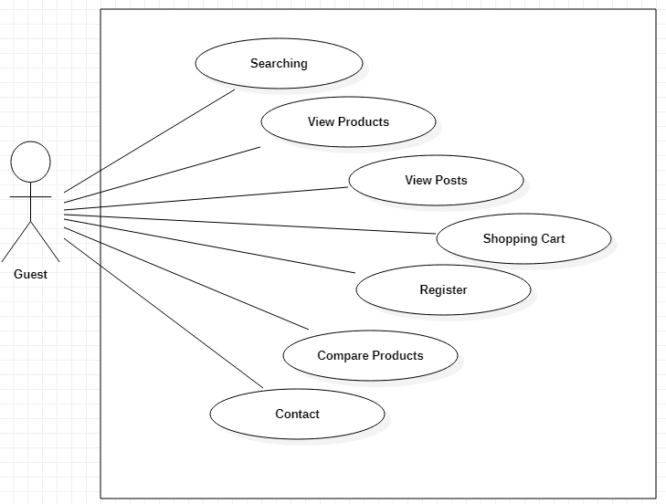

|  |  |  |
| --- | --- | --- |
| **Author** | Nguyễn Hoàng An | |
| **Use** **case** **name** | Button search | |
| **Actors** | Guests and members | |
| **Description** | When search button is clicked and typed, web page will be switched to product page and display all product match with key word what user typed. | |
| **Requirement** |  | |
|  | **Actor** **action** | **System** **reponses** |
| **Basic flow** | Actors input click on search button and input keyword. | System check the search string.  System create an empty list to contain search result.  Search in products table to find products with have name contain the search string and add them to result list.  Display the result list in the product page. |
| **Exception** |  |  |

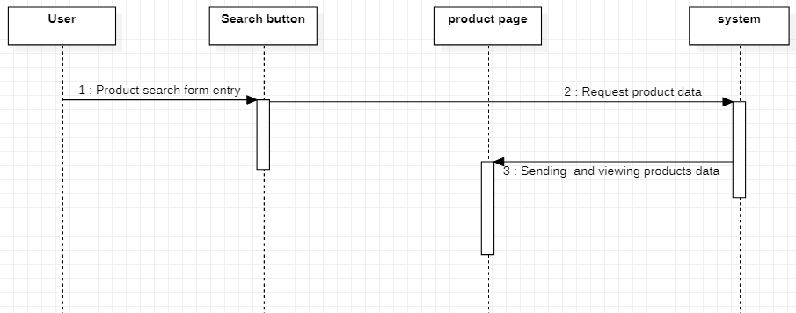

|  |  |  |
| --- | --- | --- |
| **Author** | Phạm Quang Huy | |
| **Use** **case** **name** | Product view | |
| **Actors** | Guests and members | |
| **Description** | When user click on product card, web page will switch to page product deatil and show all information of product, include: name, content, price, and show related products. | |
| **Requirement** |  | |
|  | **Actor** **action** | **System** **reponses** |
| **Basic flow** | Click on product links in name or image. | Receive slug in link and search in products table.  Display the details in the product detail page. |
| **Exception** |  |  |

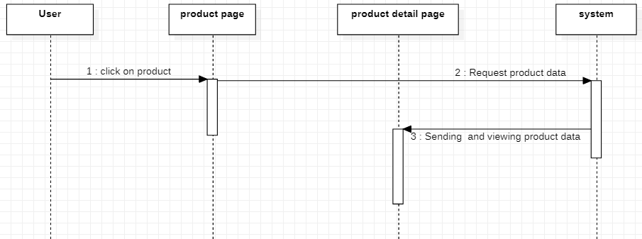

|  |  |  |
| --- | --- | --- |
| **Author** | Phạm Quang Huy | |
| **Use** **case** **name** | Post view | |
| **Actors** | Guests and members | |
| **Description** | When user click on post, web page will switch to page post deatil and show all information of post, include: name, content, written, date release. | |
| **Requirement** |  | |
|  | **Actor** **action** | **System** **reponses** |
| **Basic flow** | Click on post links in name or image. | Receive slug in link and search in posts table.  Display the details in the post detail page. |
| **Exception** |  |  |

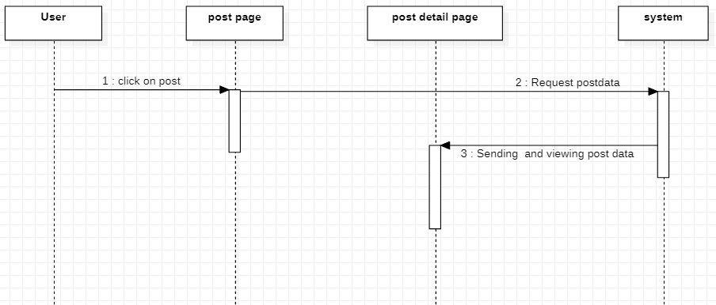

|  |  |  |
| --- | --- | --- |
| **Author** | Phạm Xuân Hoài | |
| **Use** **case** **name** | Shopping cart | |
| **Actors** | Guests and members | |
| **Description** | When users click on Add to card, number of shopping cart increase. Then click on shopping card, web page switch to cart detail. This page show all products was chosen, quantity, total price and users can update quantity and delete from cart. | |
| **Requirement** |  | |
|  | **Actor** **action** | **System** **reponses** |
| **Basic flow** | Click on Add to cart.  Update quantity in shopping cart.  Remove in shopping cart. | Add product detail to content row in shopping cart table and display to cart page include proudcts, quantity, total price.  Update quantity and change content in shopping cart table and display to cart page include products, quantity, total price.  Remove and update content row in shopping cart table and display to cart page include proudcts, quantity, total price. |
| **Exception** |  |  |

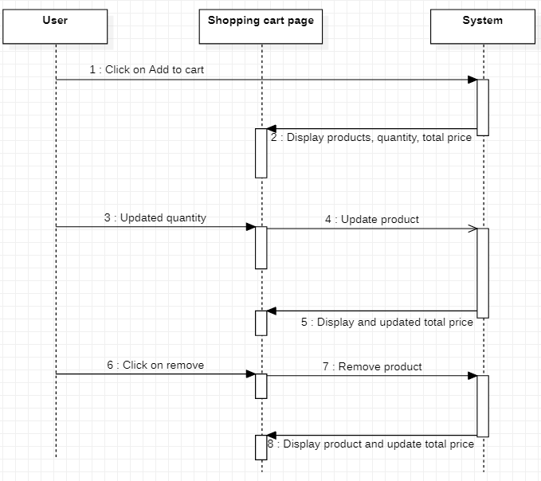

|  |  |  |
| --- | --- | --- |
| **Author** | Phạm Quang Huy | |
| **Use** **case** **name** | Register | |
| **Actors** | Guests and members | |
| **Description** | Guests want to register to become a member. | |
| **Requirement** |  | |
|  | **Actor** **action** | **System** **reponses** |
| **Basic flow** | Input information and click on register. | Check validation.  Create account.  Display login page. |
| **Exception** | Field name blank.  Field email blank.  Field password blank.  Field phone blank.  Field address required.  Name format.  Email unique.  Email format | Display error message:  “Tên chưa được nhập”  “Email chưa được nhập”  “Mật khẩu chưa được nhập”  “SĐT chưa được nhập”  “Địa chỉ chưa được nhập”  “Tên không hợp lệ”  “Email đã tồn tại”  “Email không hợp lệ” |

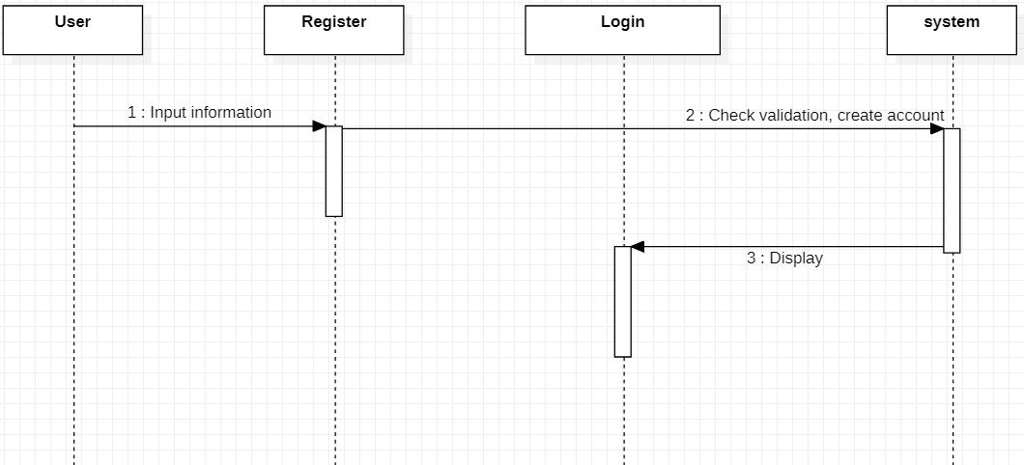

|  |  |  |
| --- | --- | --- |
| **Author** | Phạm Quang Huy | |
| **Use** **case** **name** | Compare Products | |
| **Actors** | Members and Guests | |
| **Description** | Members and Guests can compare price of products what they choice. | |
| **Requirement** |  | |
|  | **Actor** **action** | **System** **reponses** |
| **Basic flow** | Click on compare button. | System create array session and sort product by price. |
| **Exception** |  |  |

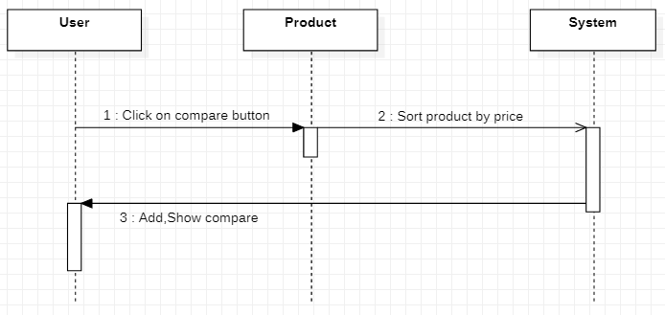

|  |  |  |
| --- | --- | --- |
| **Author** | Nguyễn Hoàng An | |
| **Use** **case** **name** | Contact Mail | |
| **Actors** | Members and Guests | |
| **Description** | Members and Guests can send email for assistance. | |
| **Requirement** |  | |
|  | **Actor** **action** | **System** **reponses** |
| **Basic flow** | Enter the content in the form and click on submit button. | System check validation and send mail to user’s gmail. |
| **Exception** | Name field blank.  Email field blank.  Title field blank.  Content field blank.  Name field format.  Email field format. | Display error messages:  “Tên chưa được nhập”  “Email chưa được nhập”  “Tiêu đề chưa được nhập”  “Nội dung chưa được nhập”  “Tên không hợp lệ”  “Email không hợp lệ” |

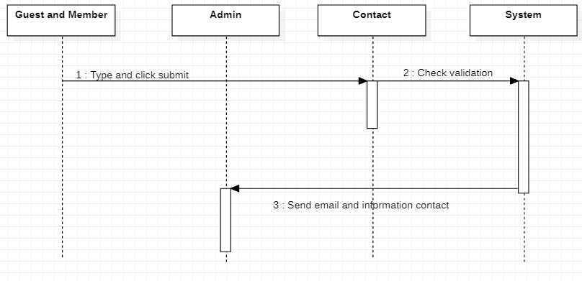

### Member

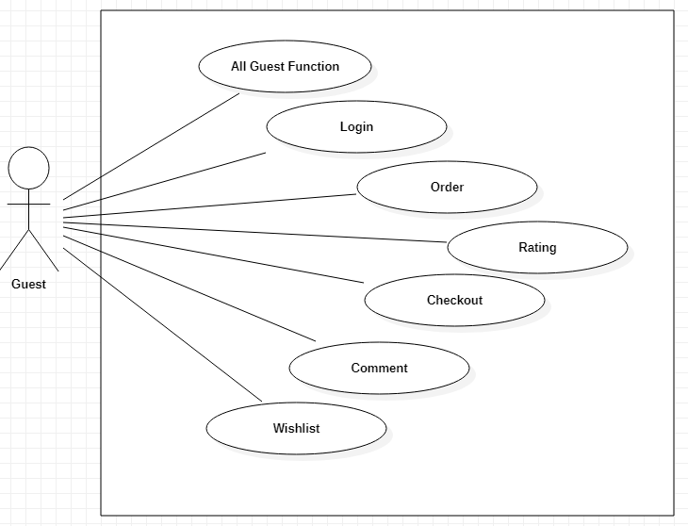

|  |  |  |
| --- | --- | --- |
| **Author** | Phạm Xuân Hoài | |
| **Use** **case** **name** | Login | |
| **Actors** | Members | |
| **Description** | User log in with their reigistered email and password. | |
| **Requirement** |  | |
|  | **Actor** **action** | **System** **reponses** |
| **Basic flow** | Input email, password and click on Log in button. | System check validation and email password in data.  System show member’s information and switch on Home page. |
| **Exception** | Field email not blank.  Field password not blank.  Email format. | Display error message:  “Email chưa được nhập”  “Mật khẩu chưa được nhập”  “Email không đúng định dạng” |

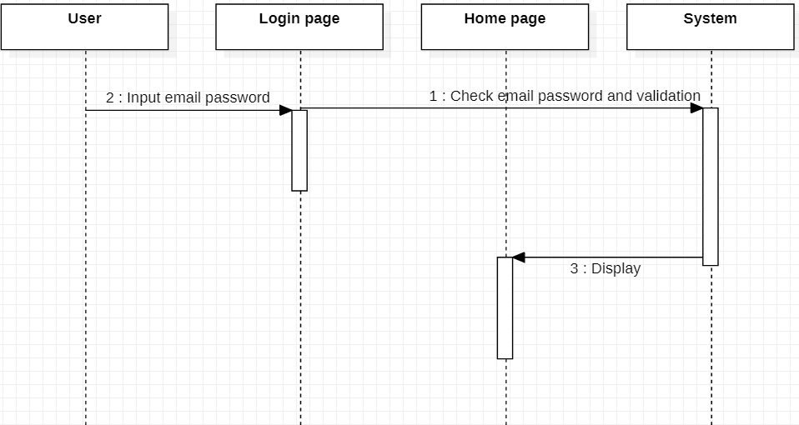

|  |  |  |
| --- | --- | --- |
| **Author** | Phạm Xuân Hoài | |
| **Use** **case** **name** | Order | |
| **Actors** | Members | |
| **Description** | Members order products in shopping cart | |
| **Requirement** | Log in | |
|  | **Actor** **action** | **System** **reponses** |
| **Basic flow** | Click on pay button | System check user id, product id, quantity and create data in order and order id table. Then return shopping cart page and send confirm message |
| **Exception** | Field email not blank.  Email format.  Field password not blank | Display error message:  “Email chưa được nhập”  “Email không hợp lệ”  “Mật khẩu chưa được nhập” |

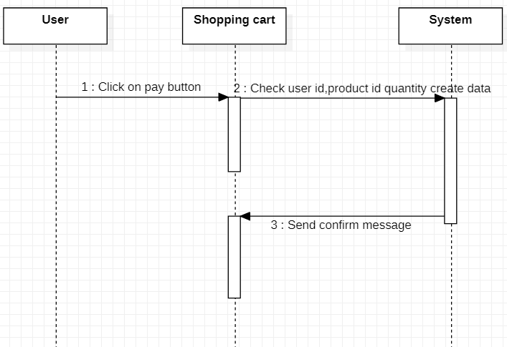

|  |  |  |
| --- | --- | --- |
| **Author** | Phạm Xuân Hoài | |
| **Use** **case** **name** | Comment | |
| **Actors** | Members | |
| **Description** | Members type and post their comment in post-details page. | |
| **Requirement** | Login | |
|  | **Actor** **action** | **System** **reponses** |
| **Basic flow** | Type comment and click on submit. | System check validation, then create database and show this comment in this post. |
| **Exception** | Field comment not blank | Display error message  “Nội dung chưa được nhập” |

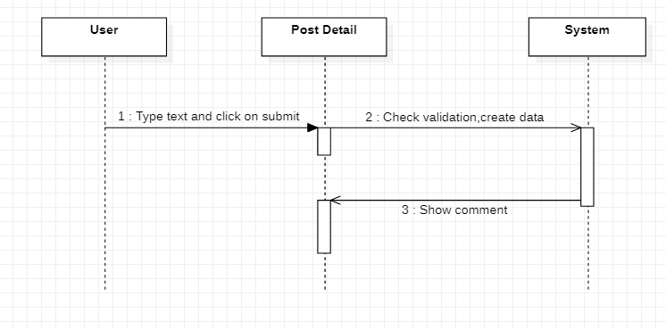

|  |  |  |
| --- | --- | --- |
| **Author** | Phạm Xuân Hoài | |
| **Use** **case** **name** | Wishlist | |
| **Actors** | Members | |
| **Description** | Members can add products to their wishlist to follow product. | |
| **Requirement** | Login | |
|  | **Actor** **action** | **System** **reponses** |
| **Basic flow** | Click on wishlish button. | System add product detail data to table wishlists. |
| **Exception** |  |  |

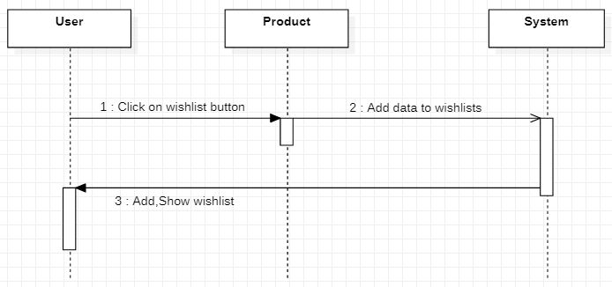

|  |  |  |
| --- | --- | --- |
| **Author** | Nguyễn Hoàng An | |
| **Use** **case** **name** | Rating | |
| **Actors** | Members | |
| **Description** | Member can rate product in product detail | |
| **Requirement** | Log in | |
|  | **Actor** **action** | **System** **reponses** |
| **Basic flow** | Click on rating in product detail | Check user id, product id, and save rating in data |
| **Exception** |  |  |

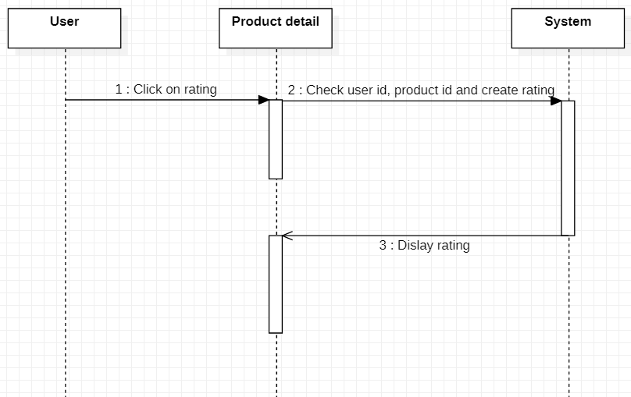

### Amin

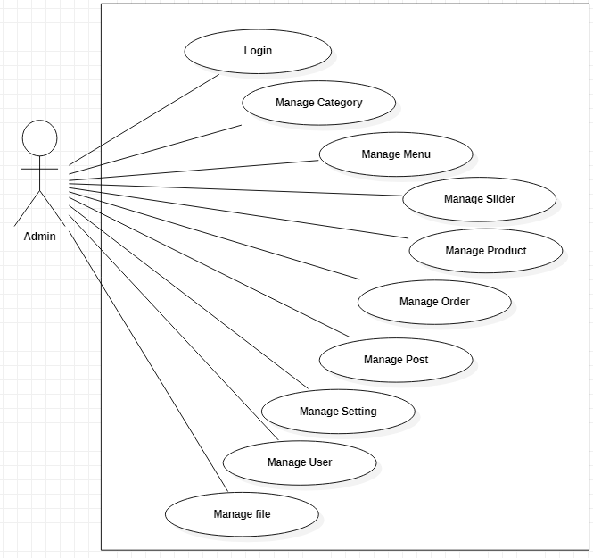

|  |  |  |
| --- | --- | --- |
| **Author** | Phạm Xuân Hoài | |
| **Use** **case** **name** | Login | |
| **Actors** | Admins | |
| **Description** | Admins go to admin page by loging in admin form. | |
| **Requirement** |  | |
|  | **Actor** **action** | **System** **reponses** |
| **Basic flow** | Entering name, password and clicking on submit button. | System checks user and password in database if it has database, system will forward to admin page. Contrary, returning login form and send the error message. |
| **Exception** | Field email not blank.  Field password not blank.  Email format. | Display error message:  “Email chưa được nhập”  “Mật khẩu chưa được nhập”  “Email không hợp lệ” |

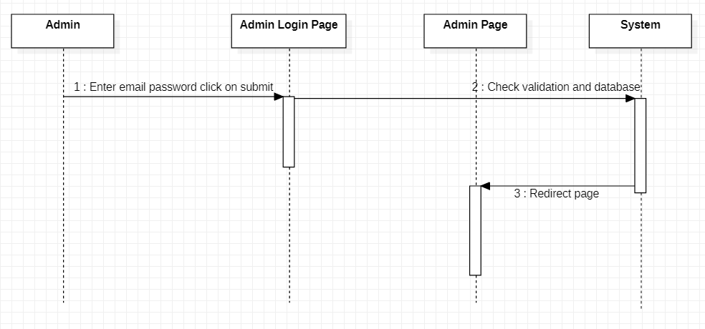

|  |  |  |
| --- | --- | --- |
| **Author** | Phạm Xuân Hoài | |
| **Use** **case** **name** | Manage Category | |
| **Actors** | Admins | |
| **Description** | Admin can see, search, sort, create, edit, delete category. | |
| **Requirement** | Login | |
|  | **Actor** **action** | **System** **reponses** |
| **Basic flow** | Click on category index to see all category data.  Click on edit button enter content what you want to change and click on submit button.  Click on delete button to delete category.  Type and click on submit to create new category.  Enter keyword to search category.  Click on table header to sort data. | System take all category data and show all.  System will redirect to edit page, check validation and update data after admins click on update button.  System deletes category was chosen in database.  System check validation and create data.  System check keyword and show matching entities.  System sort data by name, id, status,… |
| **Exception** | Field name not blank.  Name unique. | Display error message:  “Tên chưa được nhập”  “Tên đã tồn tại” |

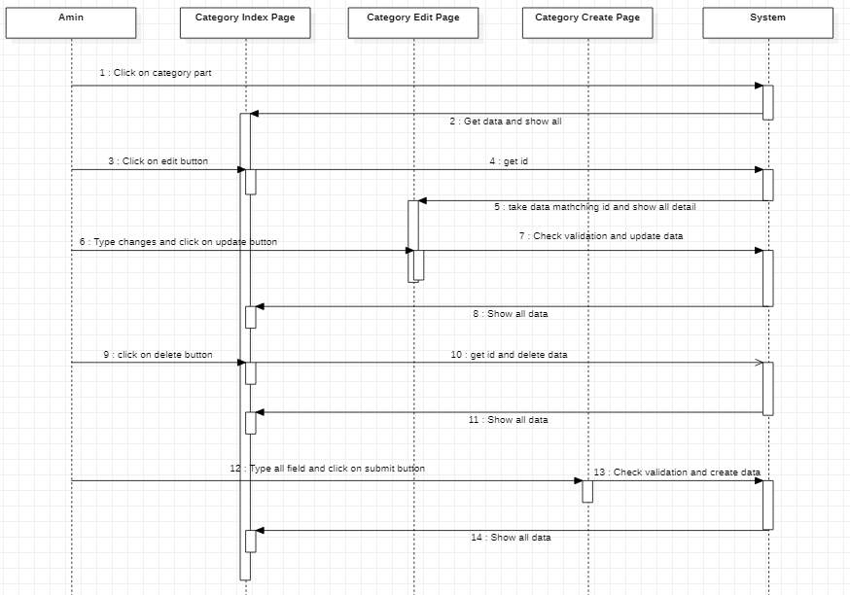

|  |  |  |
| --- | --- | --- |
| **Author** | Phạm Quang Huy | |
| **Use** **case** **name** | Manage Menu | |
| **Actors** | Admins | |
| **Description** | Admin can see, search, sort, create, edit, delete menu. | |
| **Requirement** | Login | |
|  | **Actor** **action** | **System** **reponses** |
| **Basic flow** | Click on menu index to see all menu data.  Click on edit button enter content what you want to change and click on submit button.  Click on delete button to delete menu.  Type and click on submit to create new menu.  Enter keyword to search menu.  Click on table header to sort data. | System take all menu data and show all.  System will redirect to edit page, check validation and update data after admins click on update button.  System deletes menu was chosen in database.  System check validation and create data.  System check keyword and show matching entities.  System sort data by name, id, status,… |
| **Exception** | Field name not blank  Name unique | Display error message:  “Tên chưa được nhập”  “Tên đã tồn tại” |

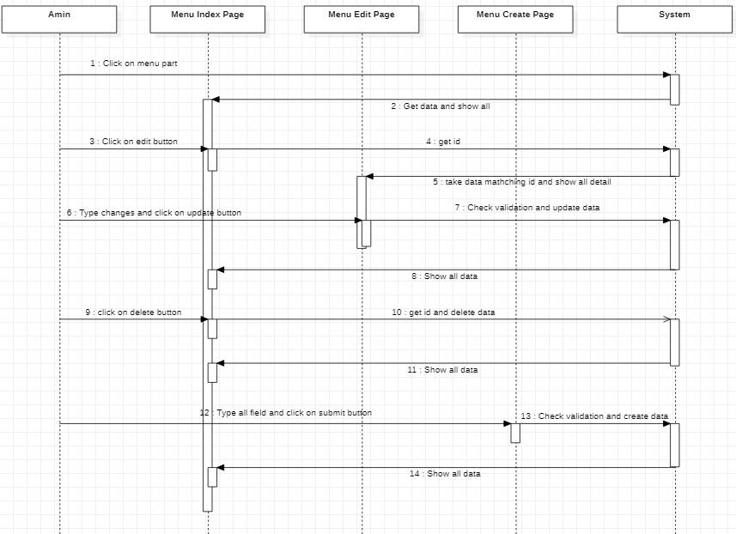

|  |  |  |
| --- | --- | --- |
| **Author** | Phạm Quang Huy | |
| **Use** **case** **name** | Manage Slider | |
| **Actors** | Admins | |
| **Description** | Admin can see, search, sort, create, edit, delete slider. | |
| **Requirement** | Login | |
|  | **Actor** **action** | **System** **reponses** |
| **Basic flow** | Click on slider index to see all slider data.  Click on edit button enter content what you want to change and click on submit button.  Click on delete button to delete slider.  Type and click on submit to create new slider.  Enter keyword to search slider.  Click on table header to sort data. | System take all slider data and show all.  System will redirect to edit page, check validation and update data after admins click on update button.  System deletes slider was chosen in database.  System check validation and create data.  System check keyword and show matching entities.  System sort data by name, id, status,… |
| **Exception** | Field link not blank  Field content not blank  Image format | Display error message:  “Link chưa được nhập”  “Nội dung chưa được nhập”  “Ảnh phải có đuôi jpg,png” |

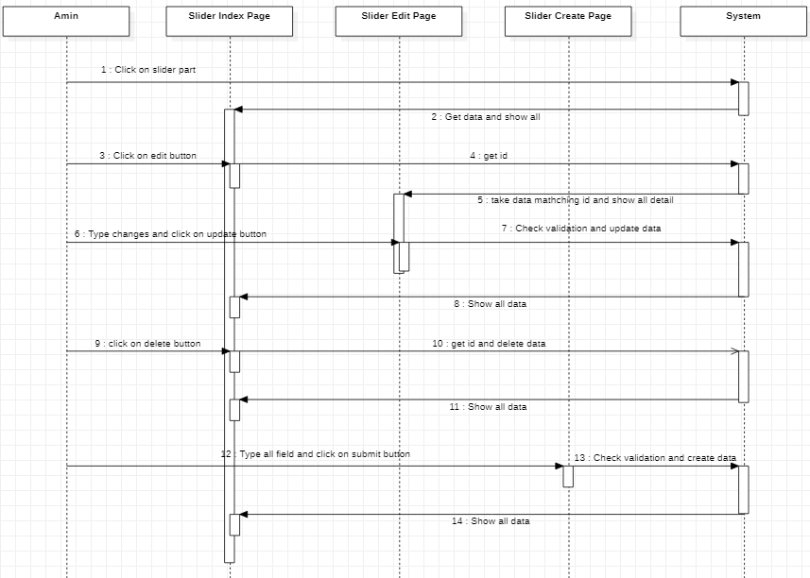

|  |  |  |
| --- | --- | --- |
| **Author** | Phạm Xuân Hoài | |
| **Use** **case** **name** | Manage Product | |
| **Actors** | Admins | |
| **Description** | Admin can see, search, sort, create, edit, delete product | |
| **Requirement** | Login | |
|  | **Actor** **action** | **System** **reponses** |
| **Basic flow** | Click on product index to see all product data.  Click on edit button enter content what you want to change and click on submit button.  Click on delete button to delete product.  Type and click on submit to create new product.  Enter keyword to search product.  Click on table header to sort data. | System take all product data and show all.  System will redirect to edit page, check validation and update data after admins click on update button.  System deletes product was chosen in database.  System check validation and create data.  System check keyword and show matching entities.  System sort data by name, id, status,… |
| **Exception** | Field name not blank.  Name unique.  Field price not blank.  Price format.  Field content not blank.  Field contentshort not blank  Image mines.  File Type.  Field Category not blank.  Field tag not blank. | Display error message:  “Tên sp chưa được nhập”  “Tên sp đã tồn tại”  “Giá sp chưa được nhập”  “Giá sp phải là chữ số”  “Nội dung chưa được nhập”  “Nội dung chưa được nhập”  “Ảnh phải có đuôi jpg,png”  “Tệp này không phải ảnh”  “Danh mục chưa chọn”  “Tag sp chưa được nhập” |

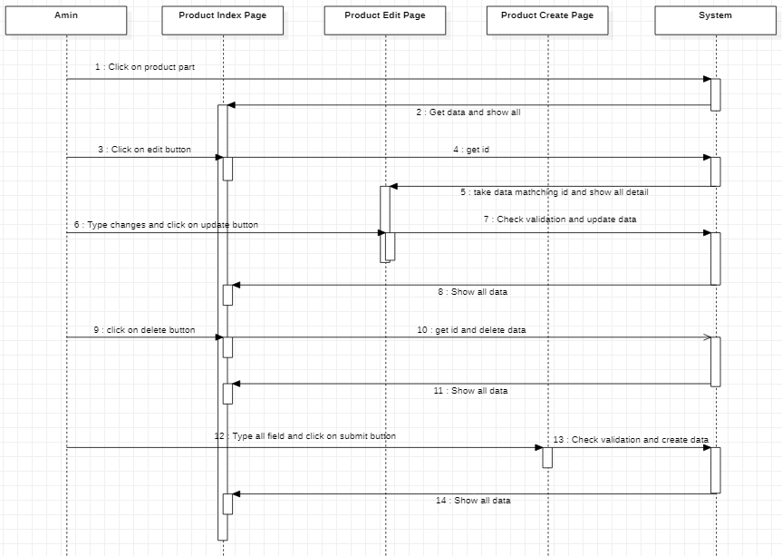

|  |  |  |
| --- | --- | --- |
| **Author** | Phạm Quang Huy | |
| **Use** **case** **name** | Manage Post | |
| **Actors** | Admins | |
| **Description** | Admin can see, search, sort, create, edit, delete post. | |
| **Requirement** | Login | |
|  | **Actor** **action** | **System** **reponses** |
| **Basic flow** | Click on post index to see all post data.  Click on edit button enter content what you want to change and click on submit button.  Click on delete button to delete post.  Type and click on submit to create new post.  Enter keyword to search post.  Click on table header to sort data. | System take all post data and show all.  System will redirect to edit page, check validation and update data after admins click on update button.  System deletes post was chosen in database.  System check validation and create data.  System check keyword and show matching entities.  System sort data by name, id, status,… |
| **Exception** | Field name not blank.  Name unique.  Field content not blank.  Image mines. | Display error message:  “Tên chưa được nhập”  “Tên bài viết đã tồn tại”  “Nội dung chưa được nhập”  “Ảnh phải có đuôi jpg,png” |

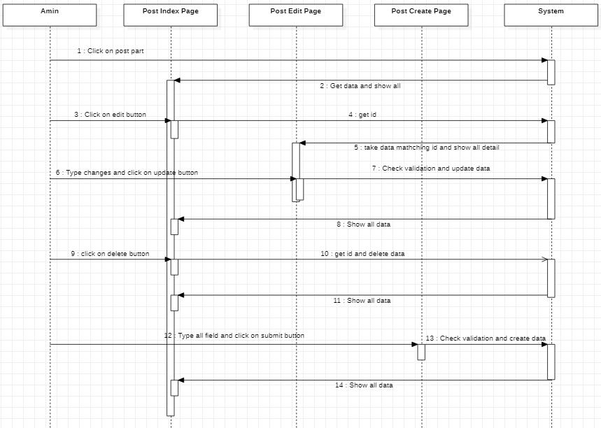

|  |  |  |
| --- | --- | --- |
| **Author** | Phạm Quang Huy | |
| **Use** **case** **name** | Manage Comment | |
| **Actors** | Admins | |
| **Description** | Admin can see, search, sort, delete comment. | |
| **Requirement** | Login | |
|  | **Actor** **action** | **System** **reponses** |
| **Basic flow** | Click on comment index to see all comment data.  Click on delete button to delete comment.  Enter keyword to search comment.  Click on table header to sort data. | System take all post data and show all.  System deletes comment was chosen in database.  System check keyword and show matching entities.  System sort data by name, id, status,… |
| **Exception** |  |  |

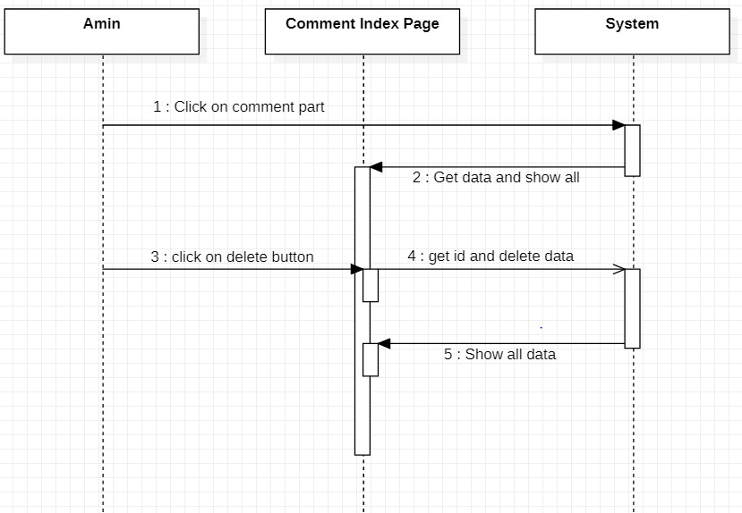

|  |  |  |
| --- | --- | --- |
| **Author** | Phạm Xuân Hoài | |
| **Use** **case** **name** | Manage Order | |
| **Actors** | Admins | |
| **Description** | Admin can see, search, sort, view, export, delete order. | |
| **Requirement** | Login | |
|  | **Actor** **action** | **System** **reponses** |
| **Basic flow** | Click on order index to see all order data.  Click on delete button to delete order.  Click on view button to see order detail.  Click on export to down file pdf order detail.  Enter keyword to search order.  Click on table header to sort data. | System take all order data and show all.  System deletes order was chosen in database.  System get id, take data and show order detail.  System get id, take data and download file pdf.  System check keyword and show matching entities.  System sort data by name, id, status,… |
| **Exception** |  |  |

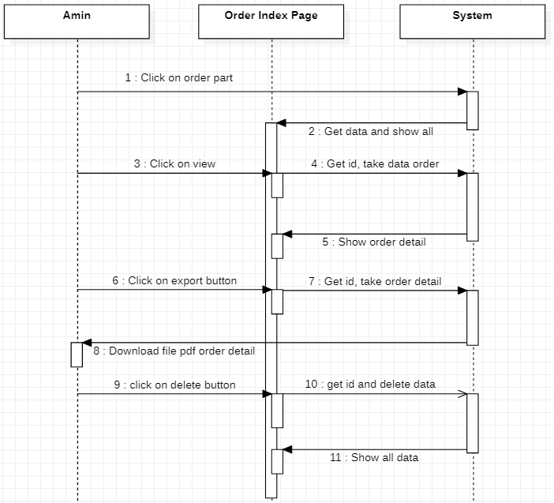

|  |  |  |
| --- | --- | --- |
| **Author** | Phạm Xuân Hoài | |
| **Use** **case** **name** | Manage setting | |
| **Actors** | Admins | |
| **Description** | Admin can see, search, sort, create, edit, delete setting | |
| **Requirement** | Login | |
|  | **Actor** **action** | **System** **reponses** |
| **Basic flow** | Click on setting index to see all setting data.  Click on edit button enter content what you want to change and click on submit button.  Click on delete button to delete setting.  Type and click on submit to create new setting.  Enter keyword to search setting.  Click on table header to sort data. | System take all setting data and show all.  System will redirect to edit page, check validation and update data after admins click on update button.  System deletes setting was chosen in database.  System check validation and create data.  System check keyword and show matching entities.  System sort data by name, id, status,… |
| **Exception** | Field config key not blank.  Config key unique. | Display error message:  “Tên chưa được nhập”  “Tên cài đặt đã tồn tại” |

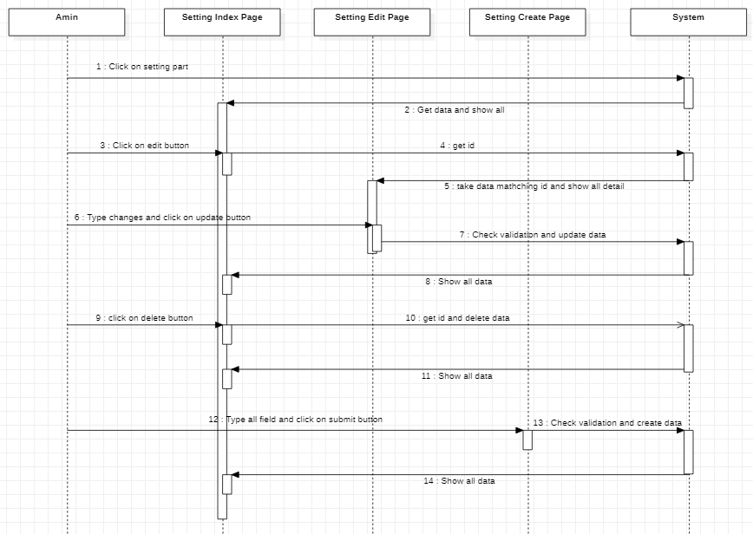

|  |  |  |
| --- | --- | --- |
| **Author** | Phạm Quang Huy | |
| **Use** **case** **name** | Manage user | |
| **Actors** | Admins | |
| **Description** | Admin can see, search, sort, create, edit, delete user | |
| **Requirement** | Login | |
|  | **Actor** **action** | **System** **reponses** |
| **Basic flow** | Click on user index to see all user data.  Click on edit button enter content what you want to change and click on submit button.  Click on delete button to delete user.  Type and click on submit to create new user.  Enter keyword to search user.  Click on table header to sort data. | System take all user data and show all.  System will redirect to edit page, check validation and update data after admins click on update button.  System deletes user was chosen in database.  System check validation and create data.  System check keyword and show matching entities.  System sort data by name, id, status,… |
| **Exception** | Field name not blank.  Name format.  Field email not blank.  Email format.  Email unique.  Field password required.  Field address required.  Field phone required.  Phone format. | Display error message:  “Tên chưa được nhập”  “Tên không hợp lệ”  “Email chưa được nhập”  “Email không hợp lệ”  “Email đã tồn tại”  “Mật khẩu chưa nhập”  “Địa chỉ chưa nhập”  “SĐT chưa được nhập”  “SĐT không hợp lệ” |

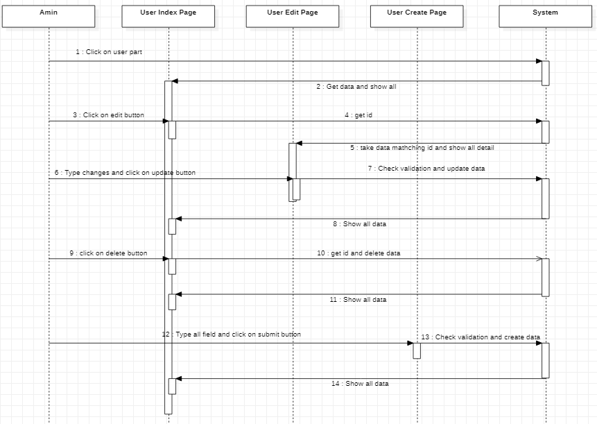

## Flow chart

### Login function(user)

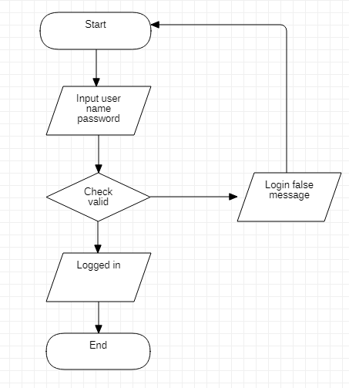

### Singup function (user)

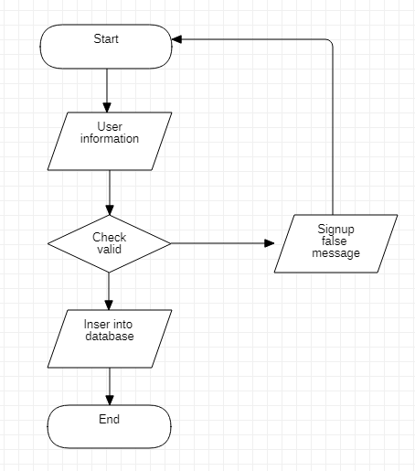

### Search function

### View data function

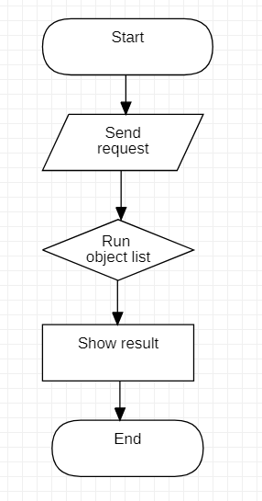

### Insert data function

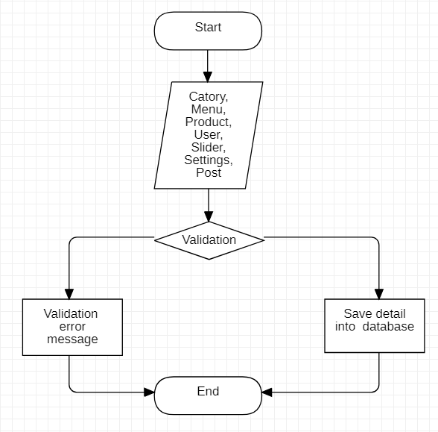

### Login function(admin)



## Sitemap

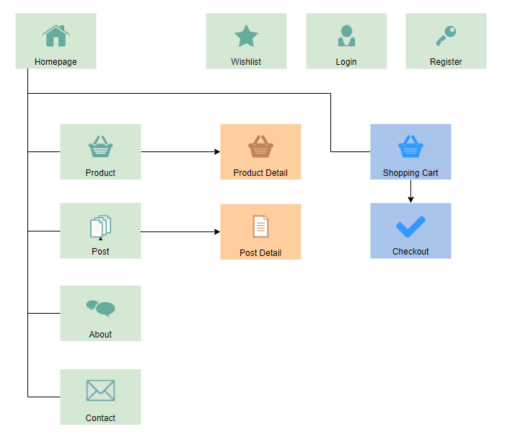

## TABLE DESIGN

### 1.Table categories

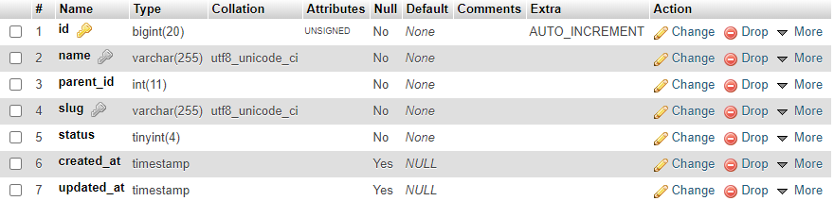

### 2.Table menus

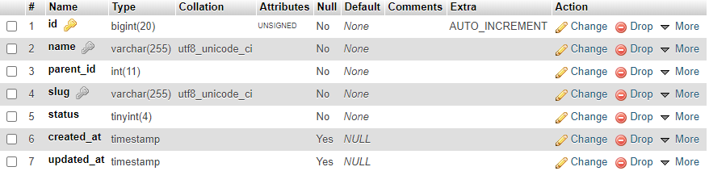

### 3.Table orders

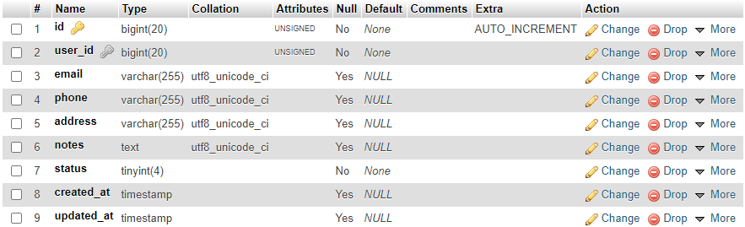

### 4.Table order_details

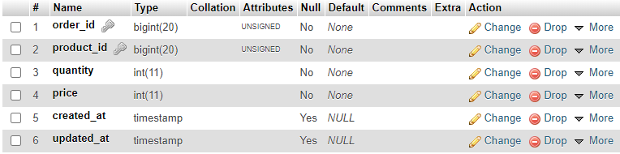

### 5.Table posts

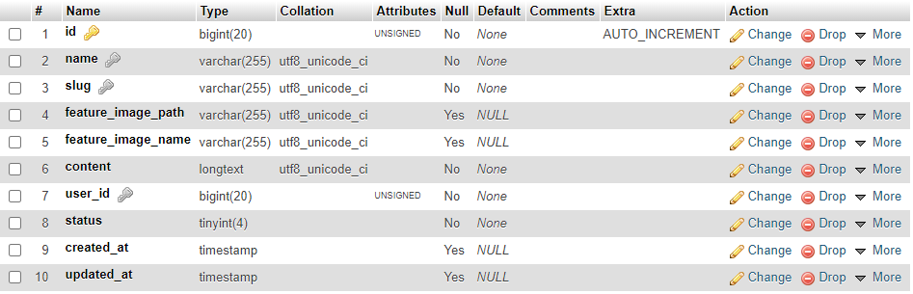

### 6.Table products

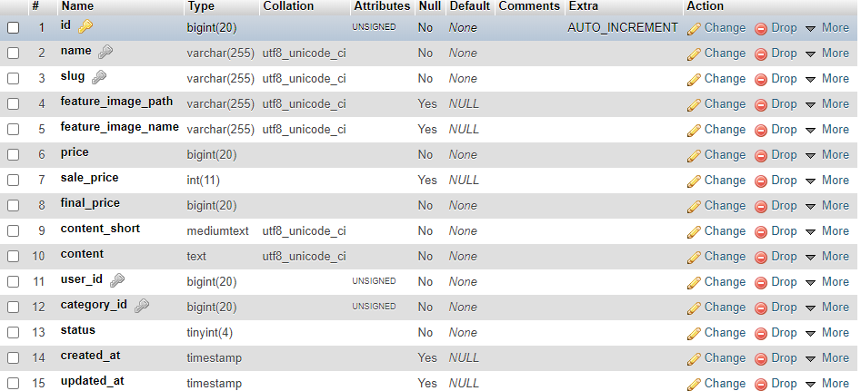

### 7.Table product_images

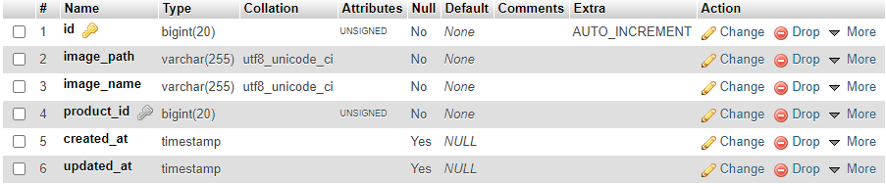

### 8.Table product_tags

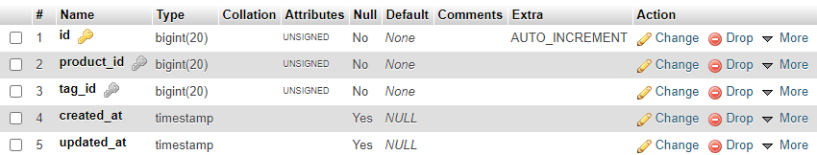

### 9.Table settings

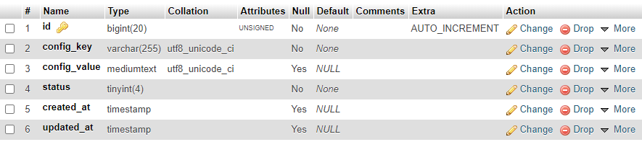

### 10.Table shoppingcart

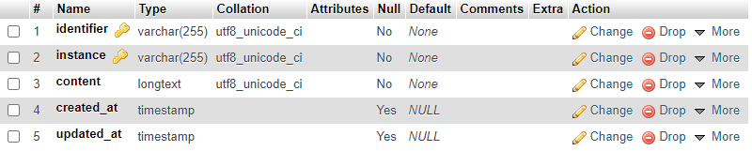

### 11.Table sliders

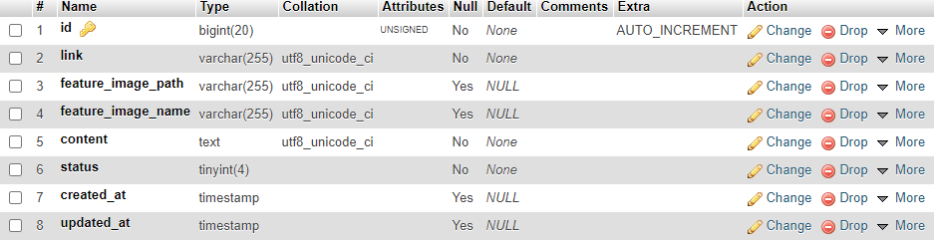

### 12.Table tags

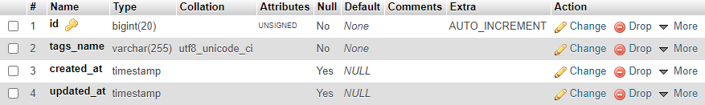

### 13.Table users

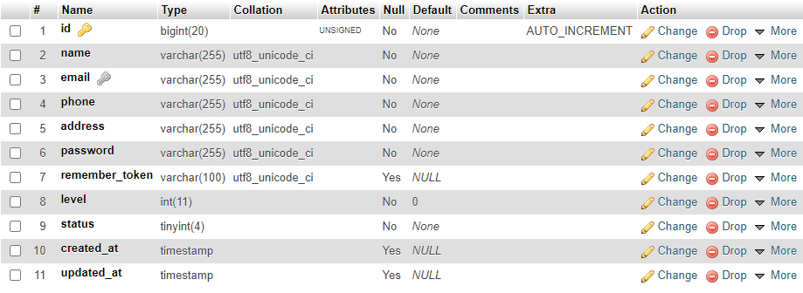

### 14.Wishlists

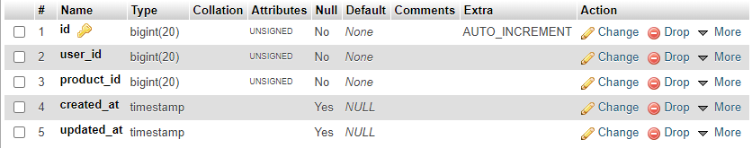

### 15. Ratings

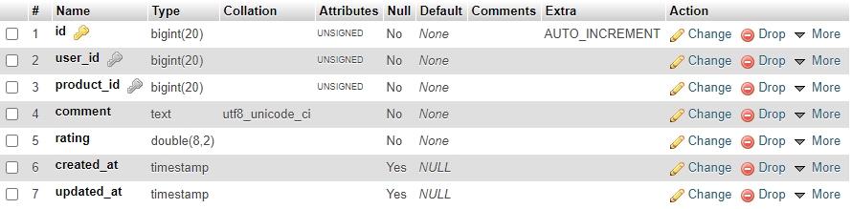

### 16.Comments

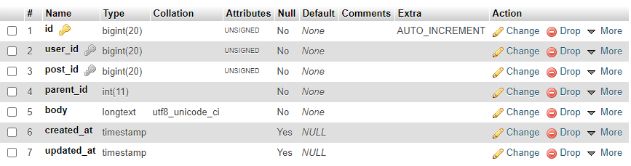

## RELATIONSHIP DIAGRAM

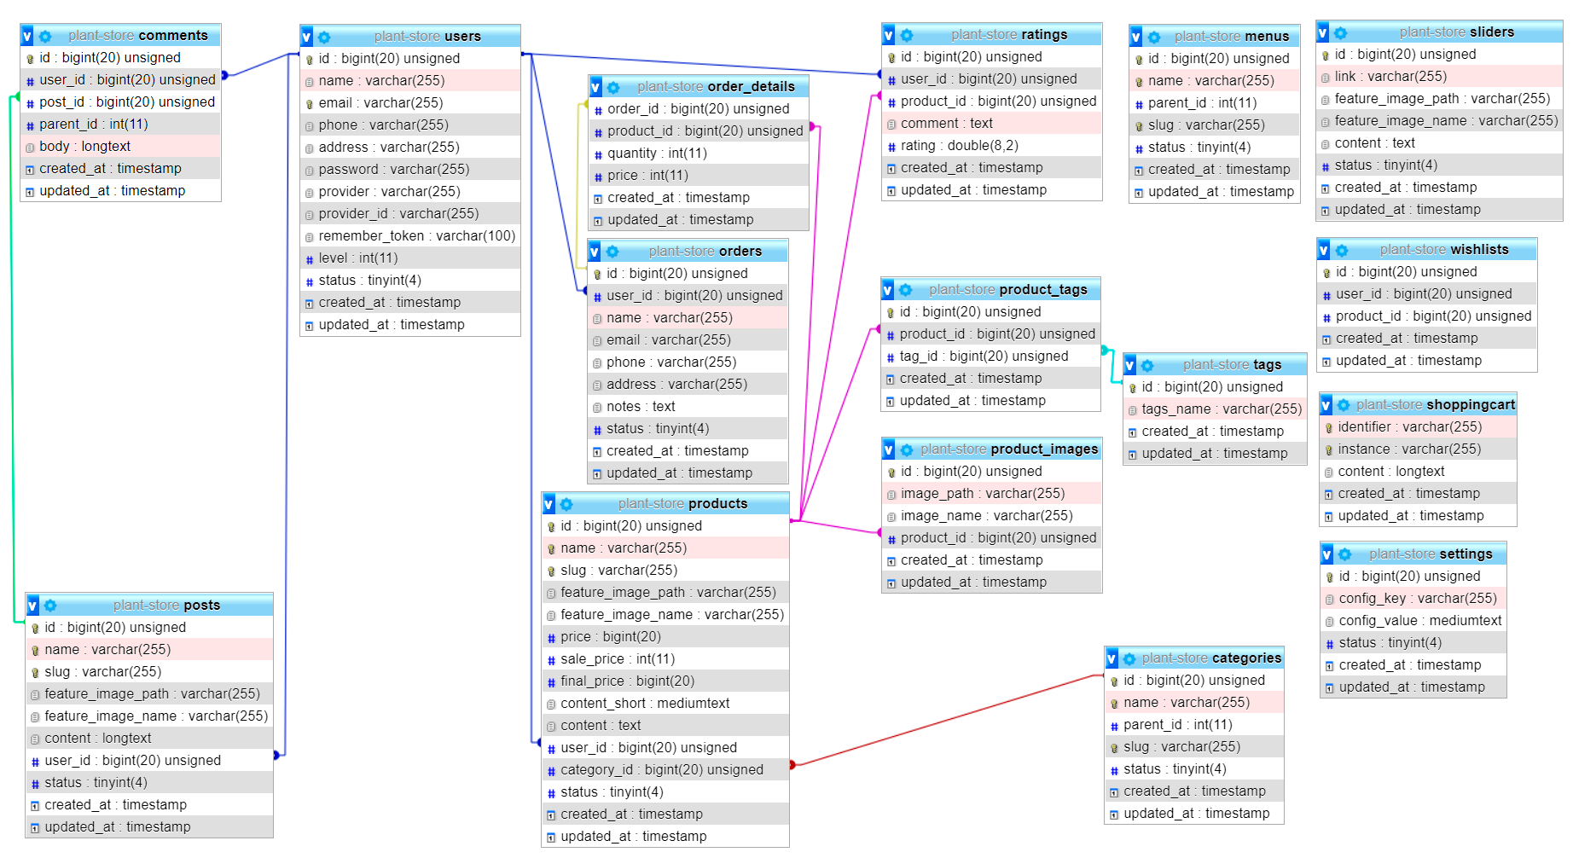

# REVIEW 3

# Customer

## 1.Home page

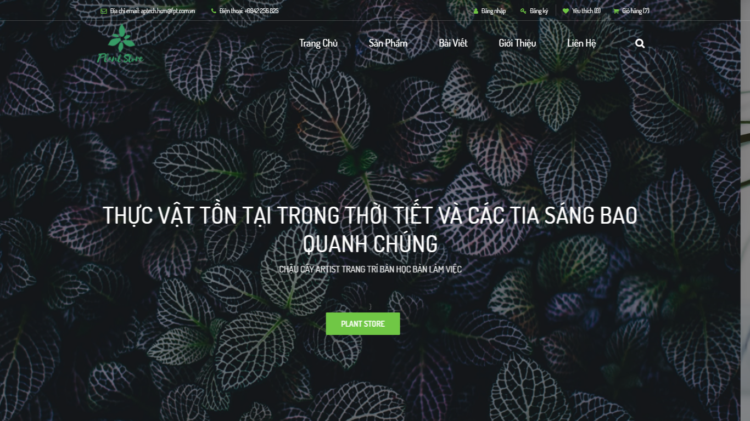

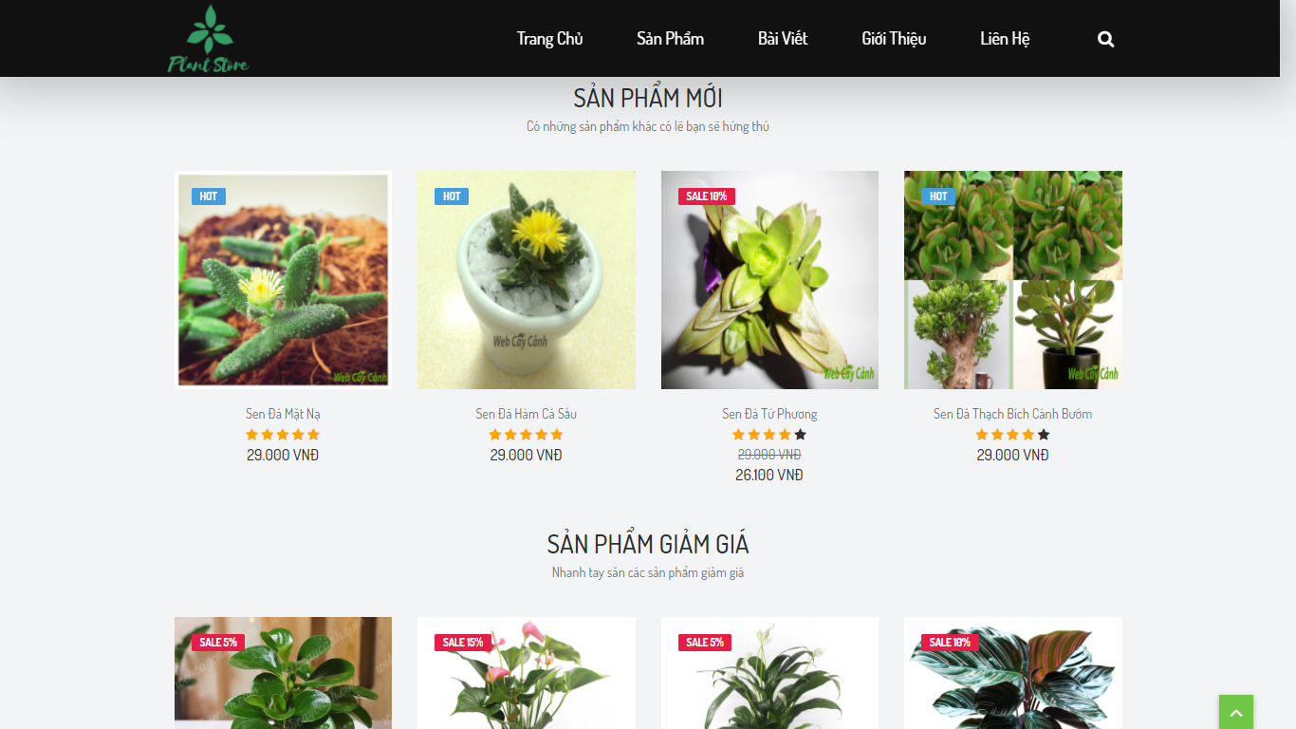

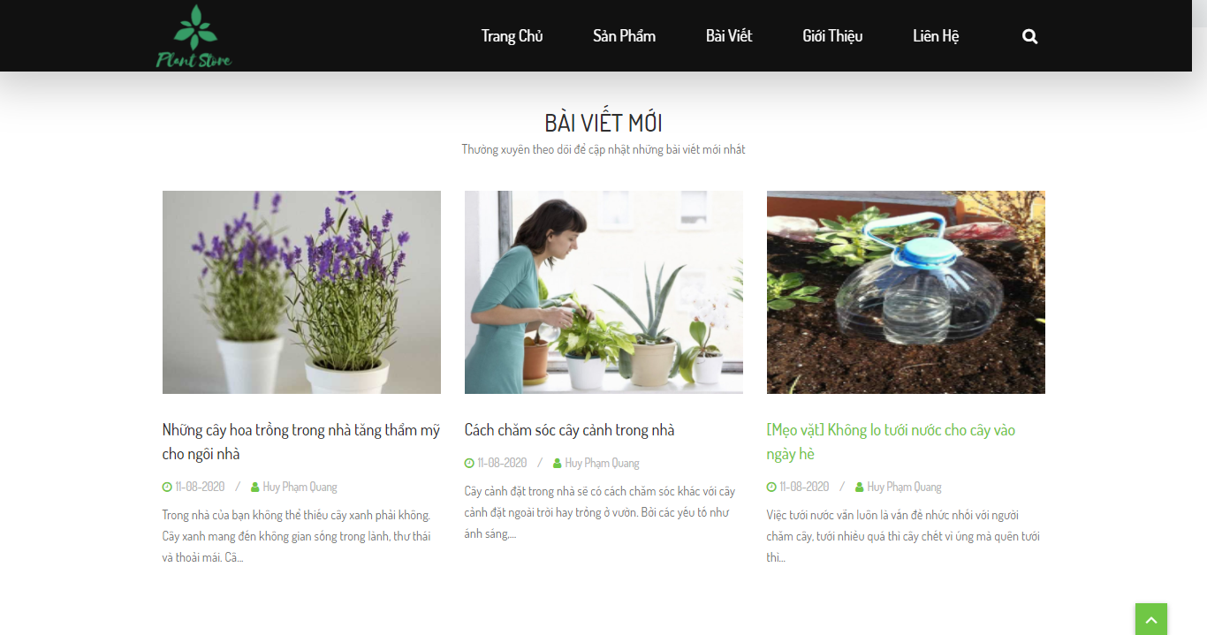

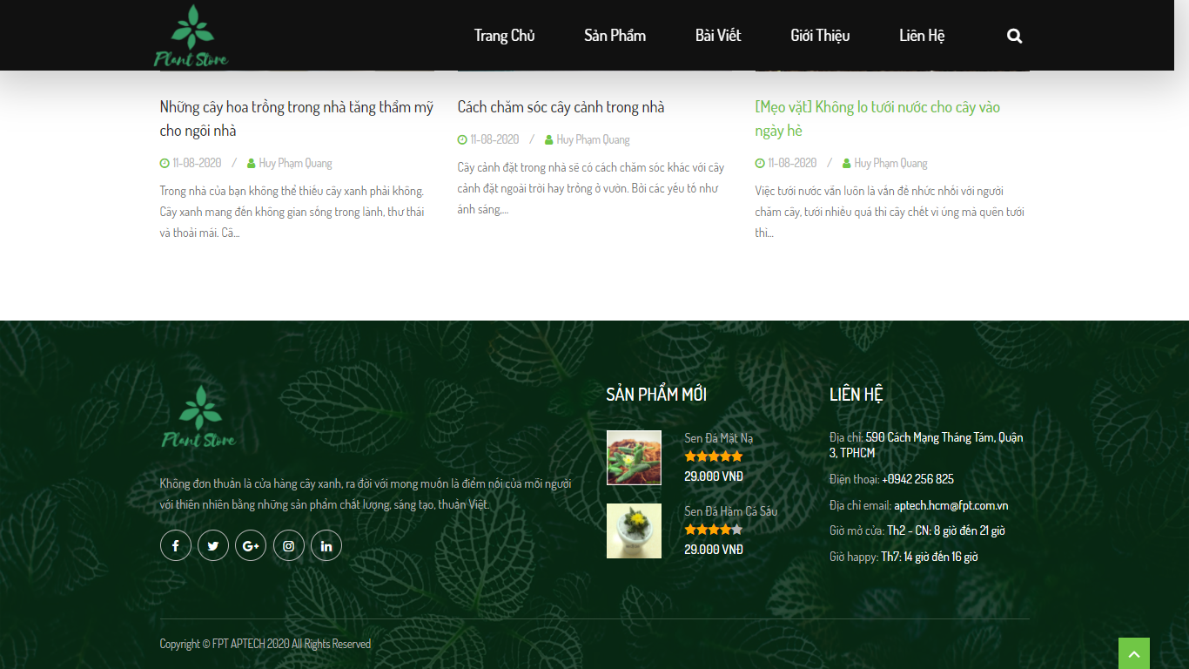

## 2.Product page

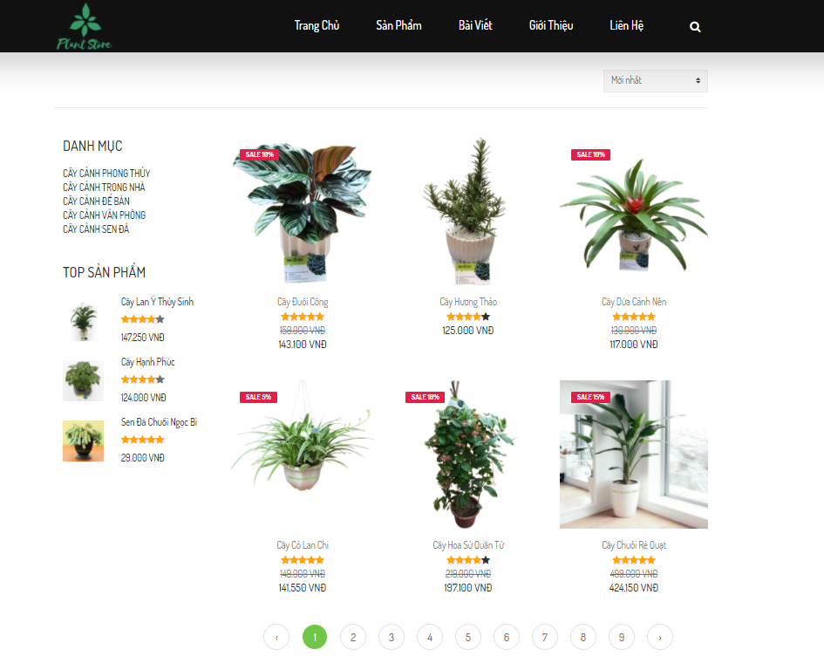

## 3.Product detail page

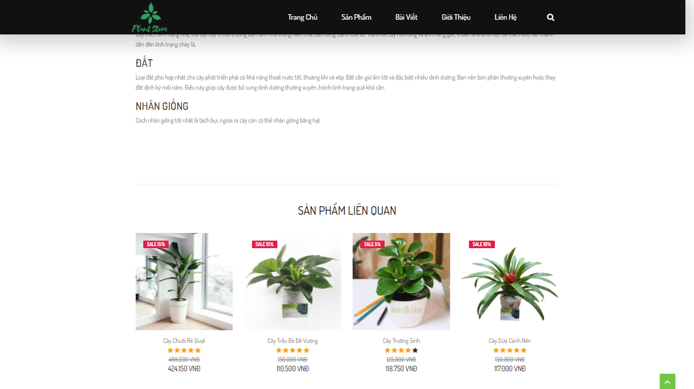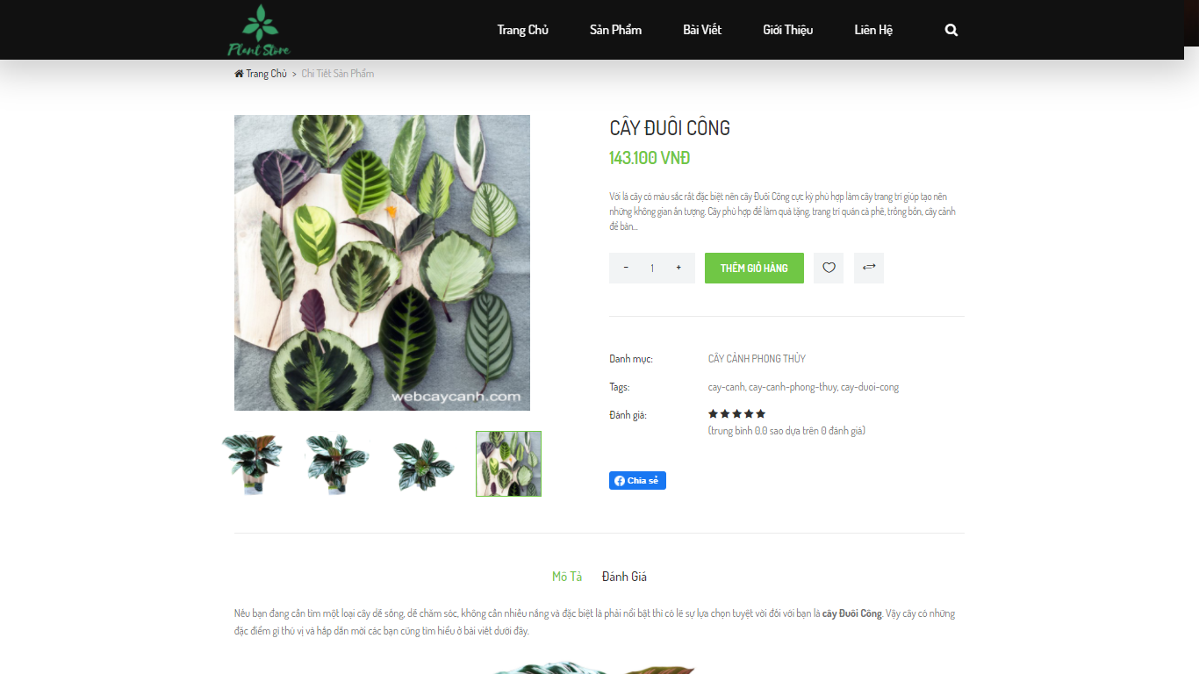

## 4.Post Page

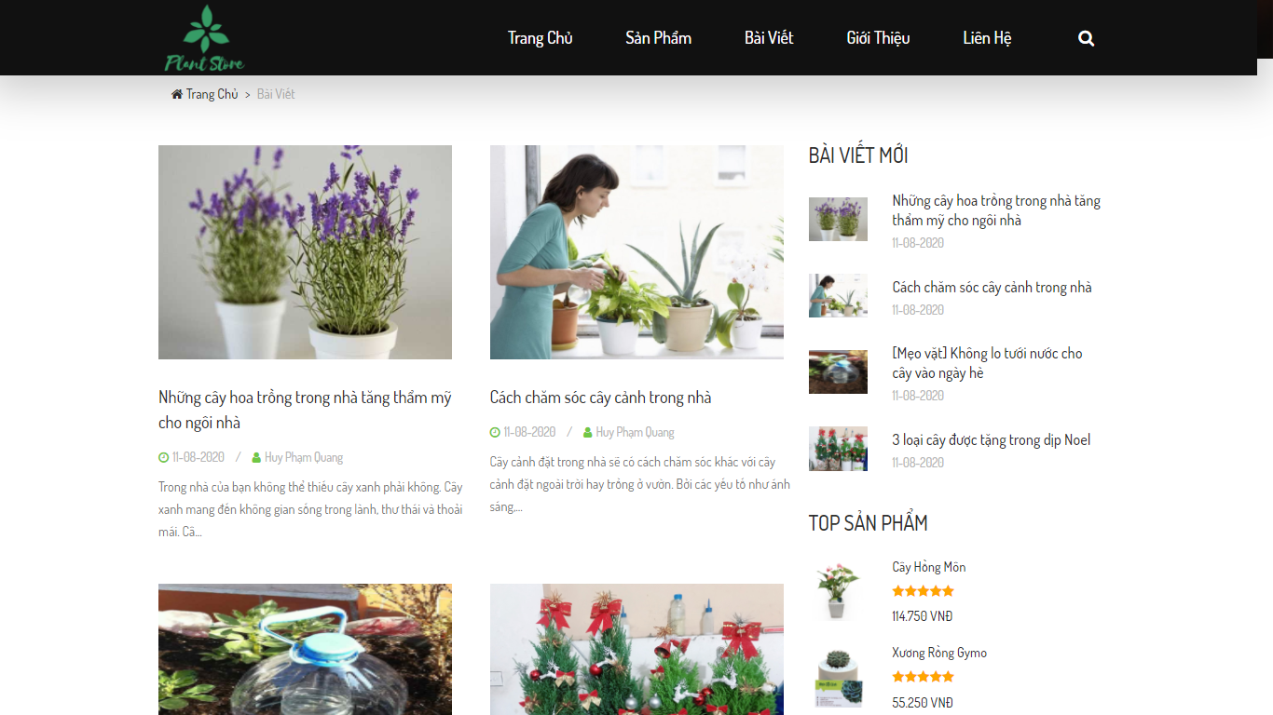

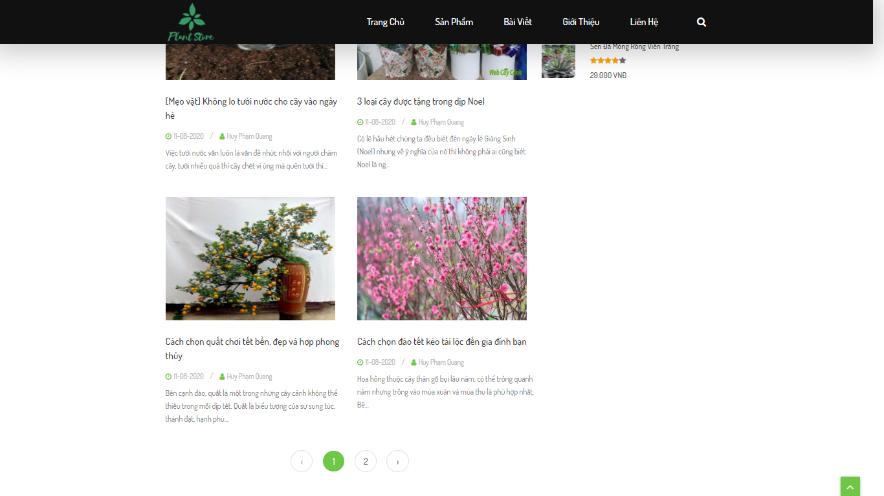

## 5.Post detail page

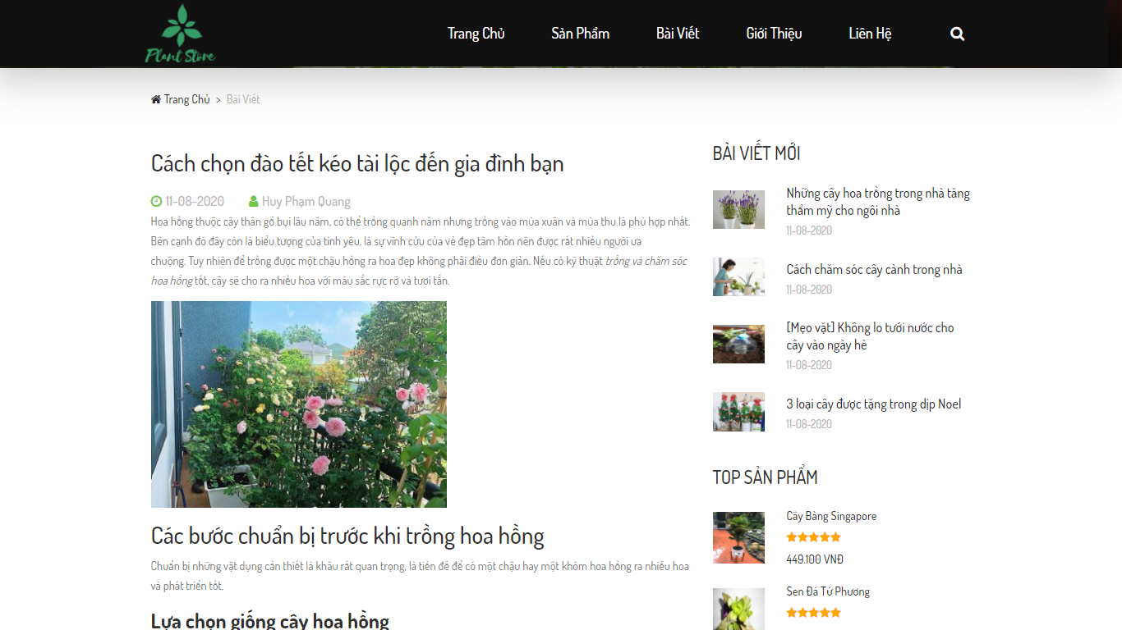

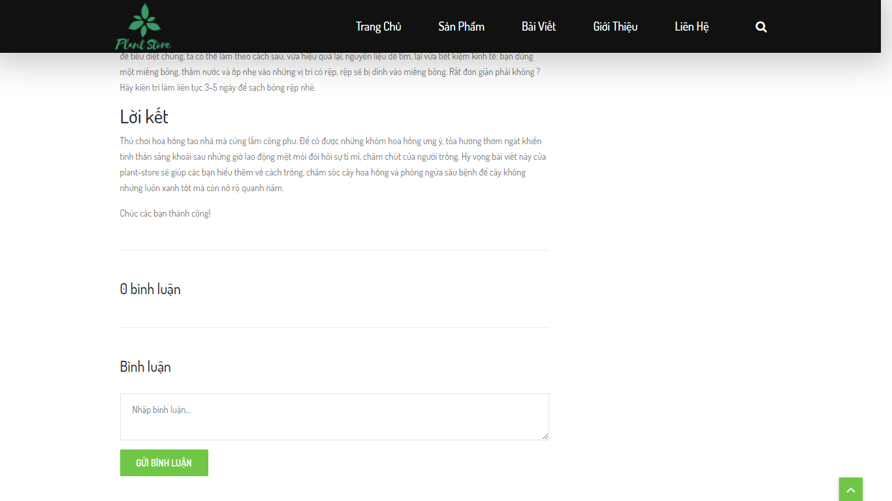

## 6.About us page

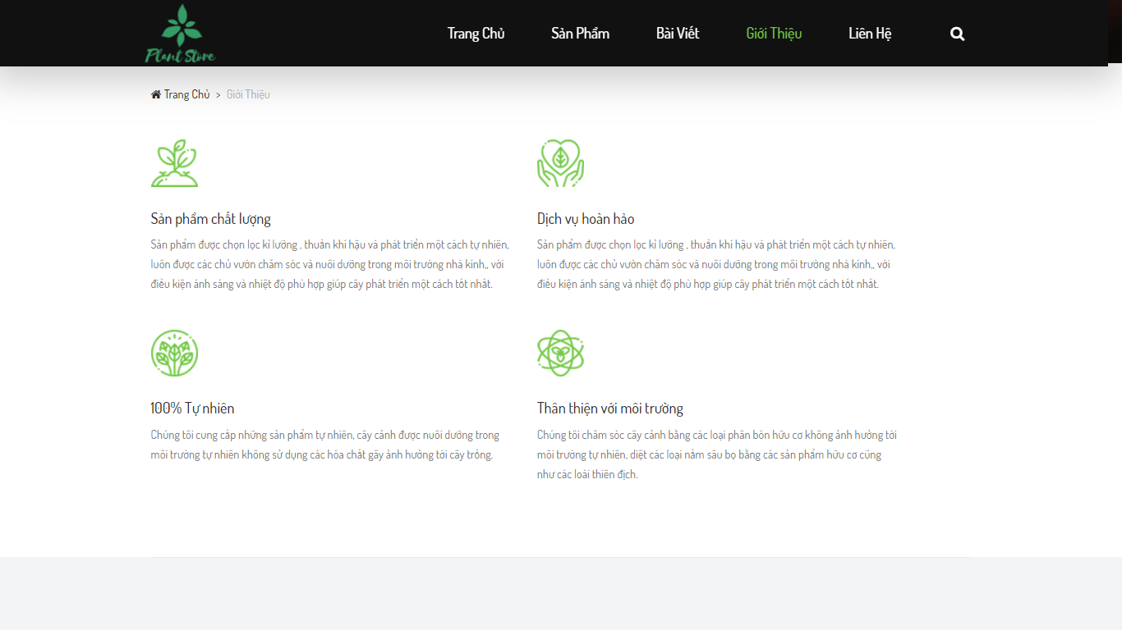

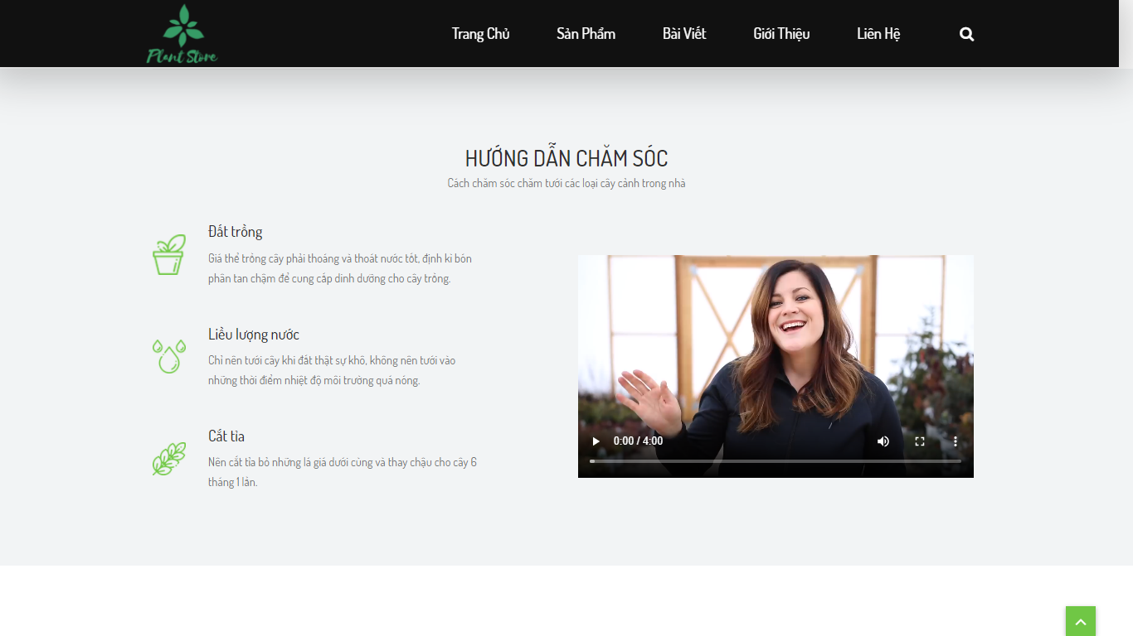

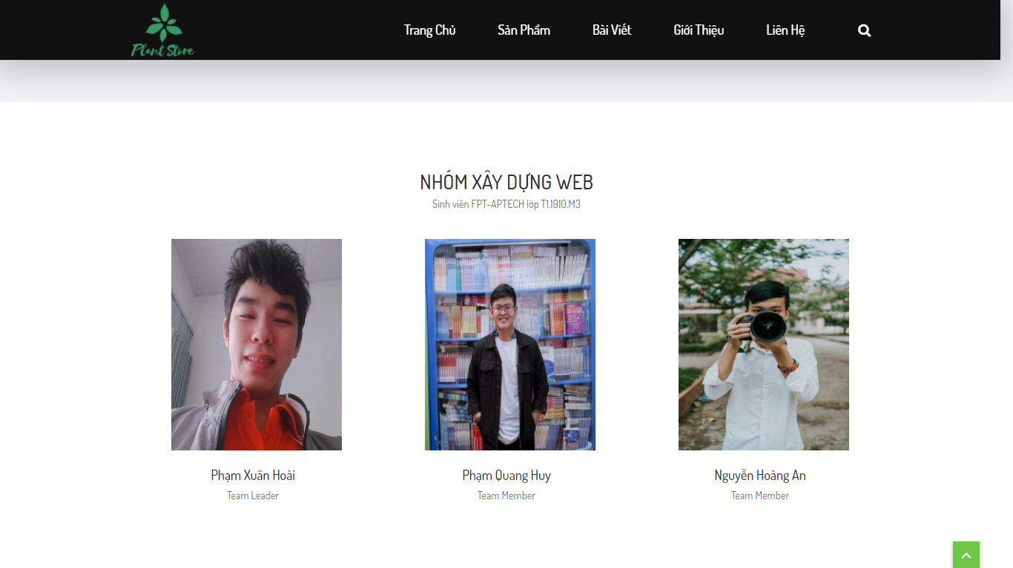

## 7.Contact page

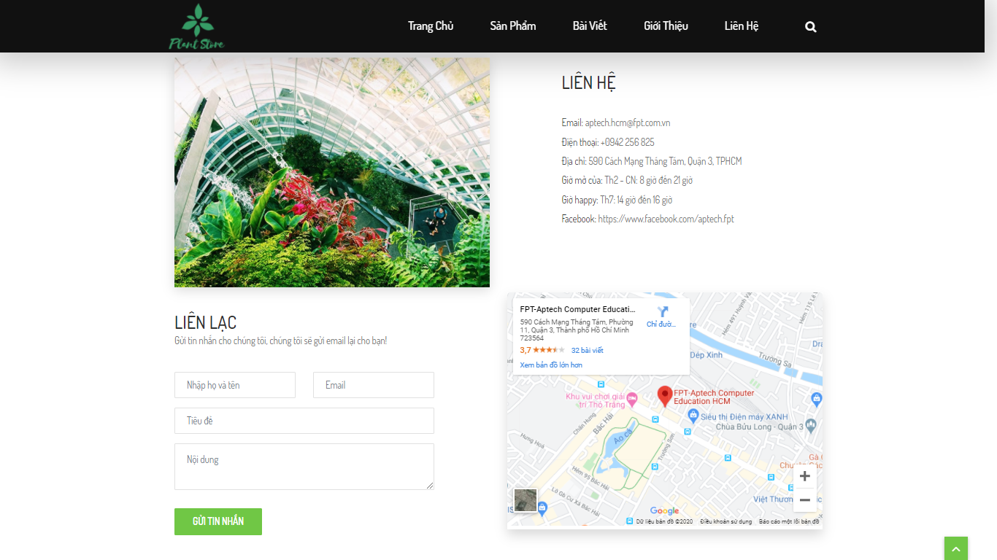

## 8.Log in page

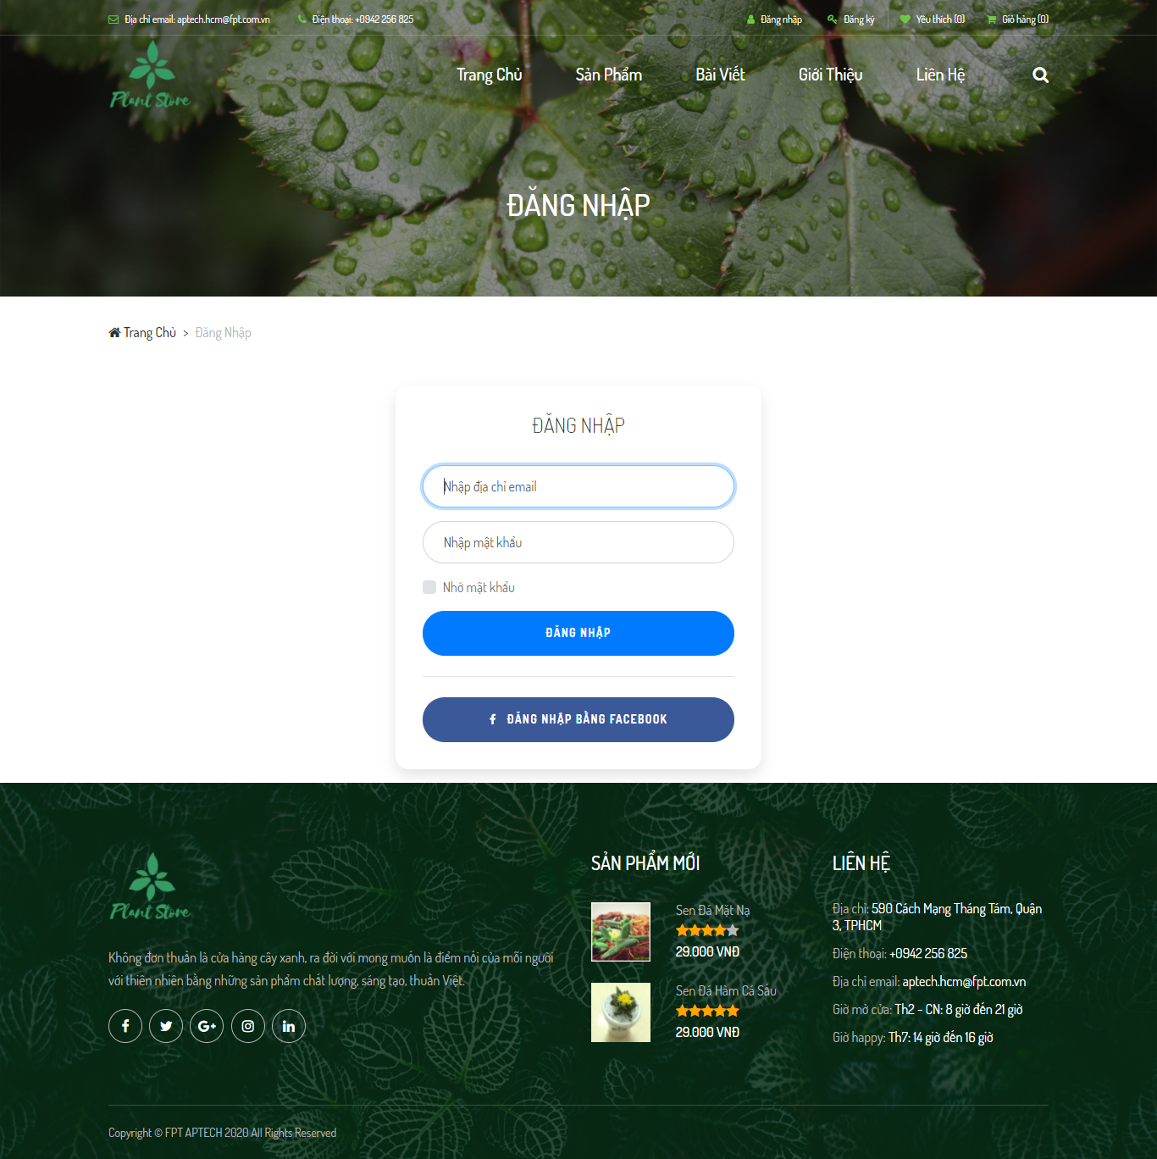

## 9.Register page

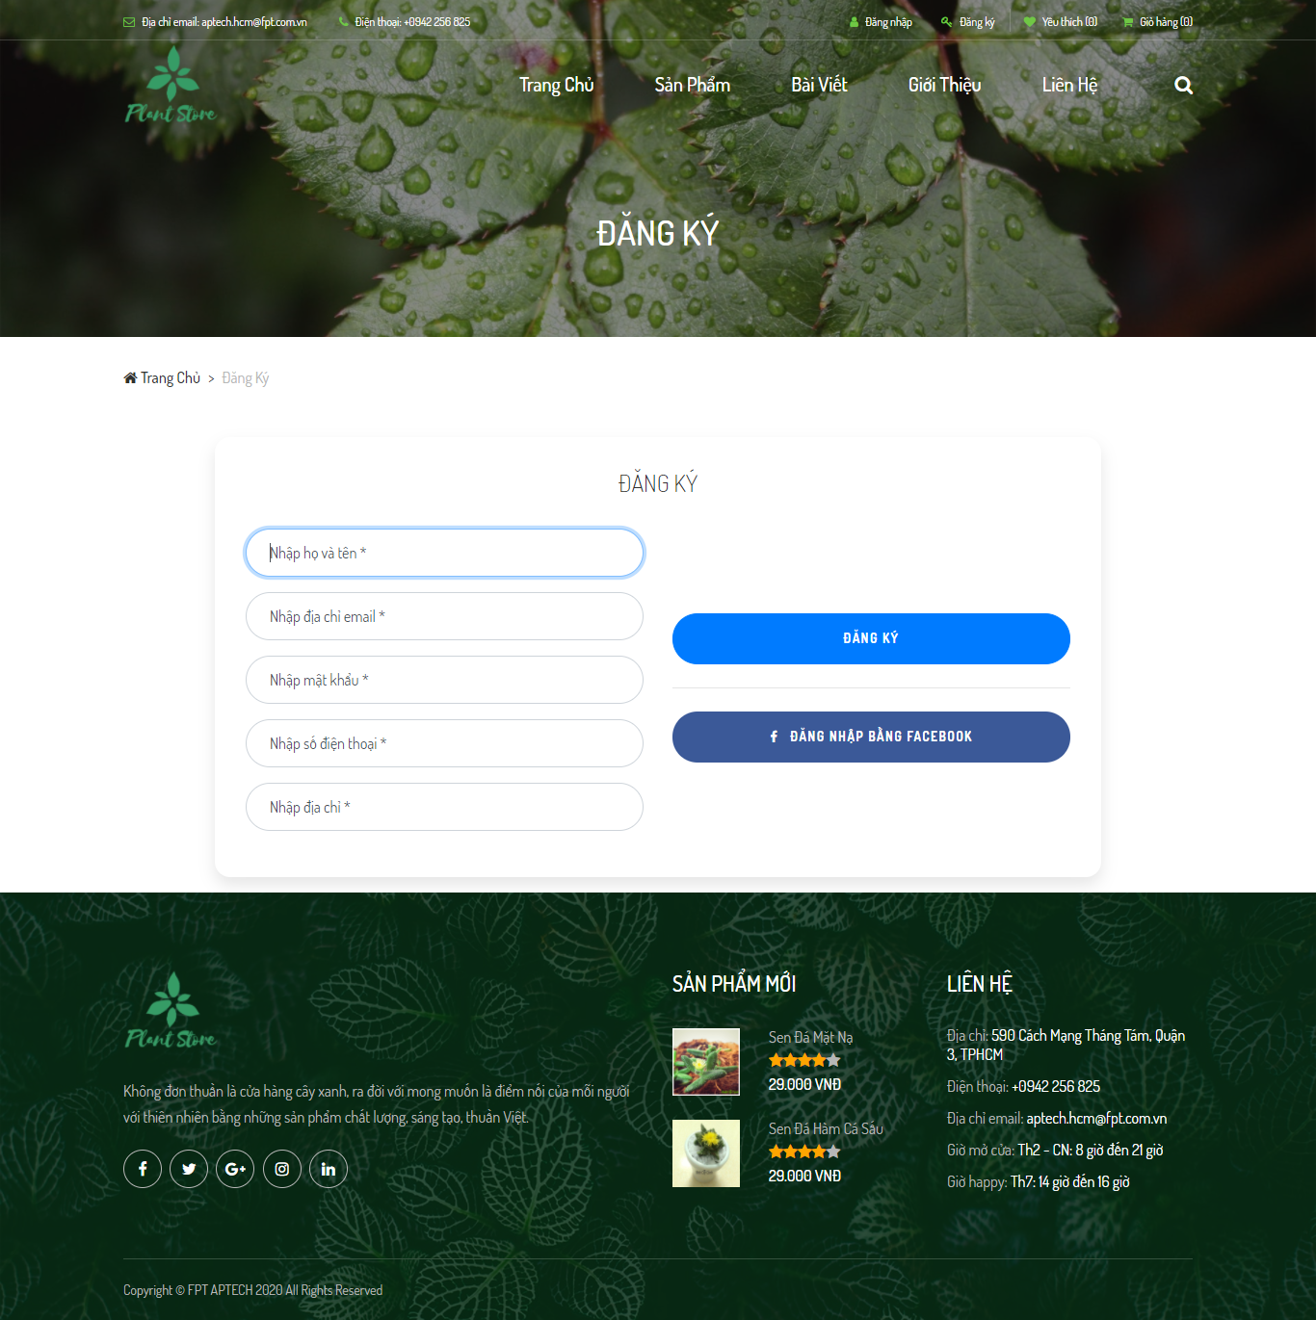

## 10.Wishlist page

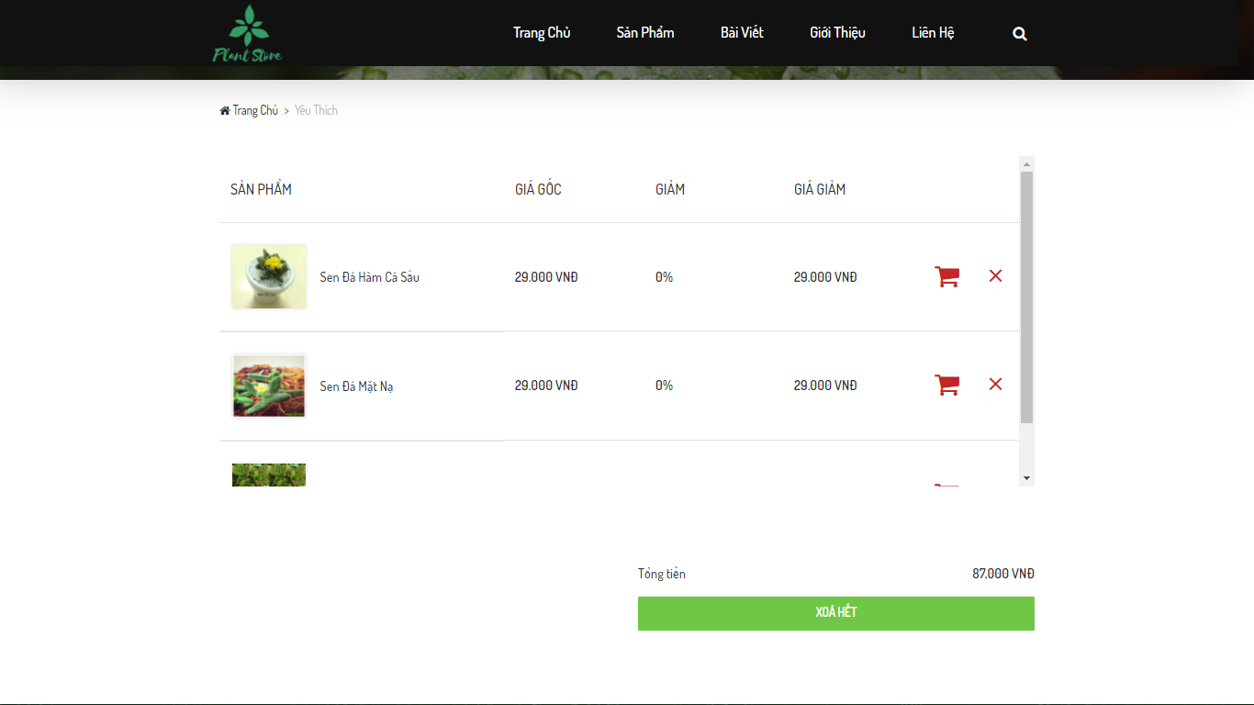

## 11.Shopping cart page

## 12.Checkout page

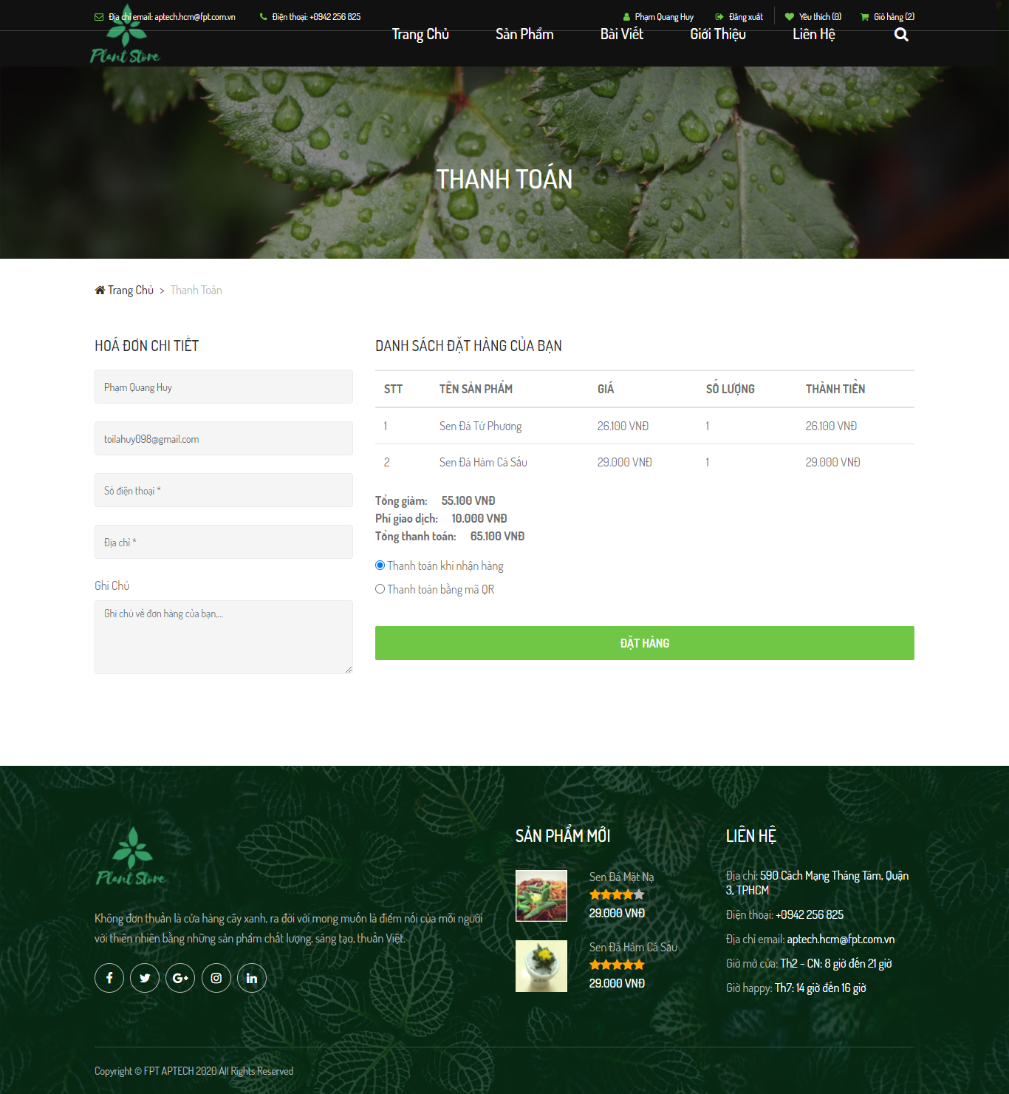

# 13.Checkout page with QR

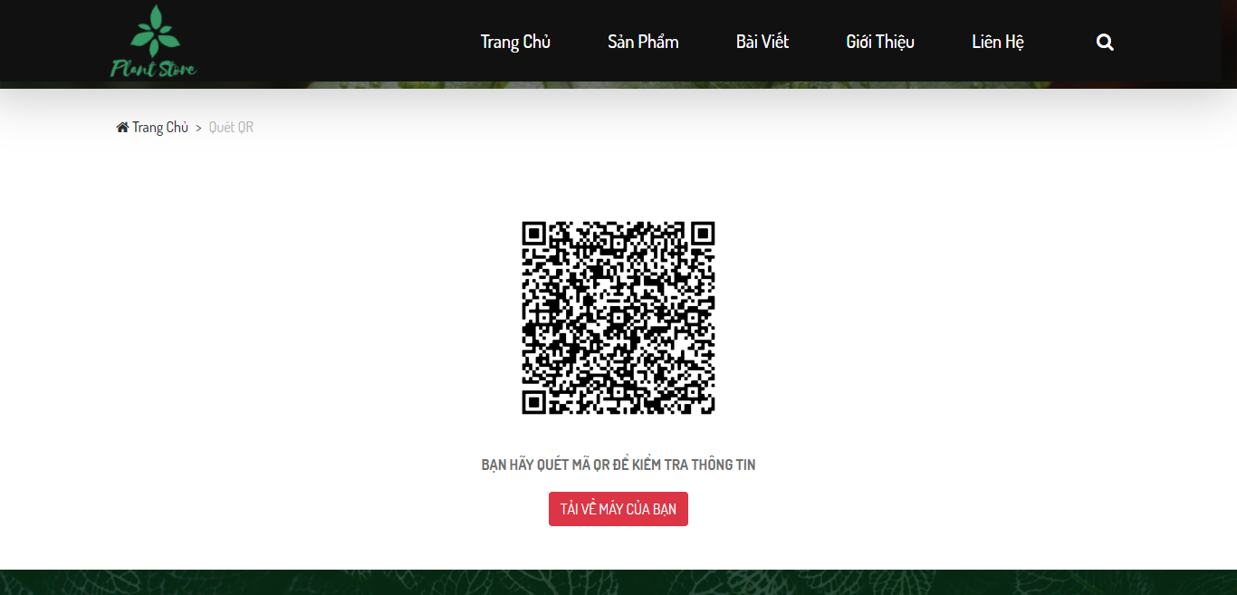

# Admin

## 1.Log in page

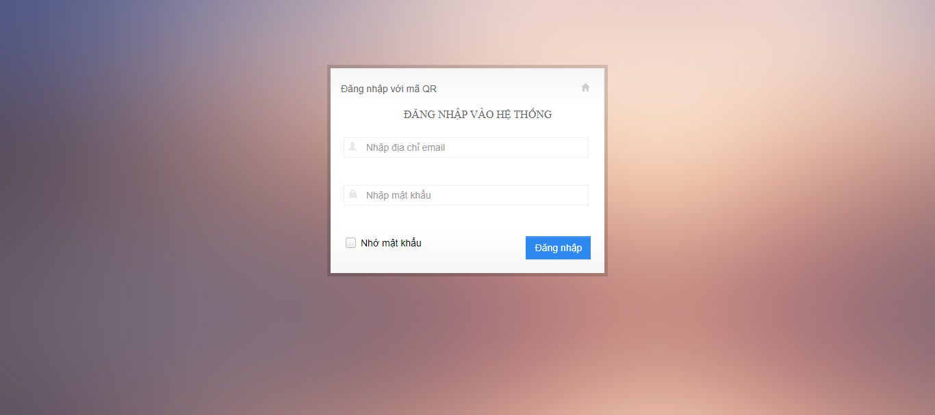

## 

## 2.Dashboard page

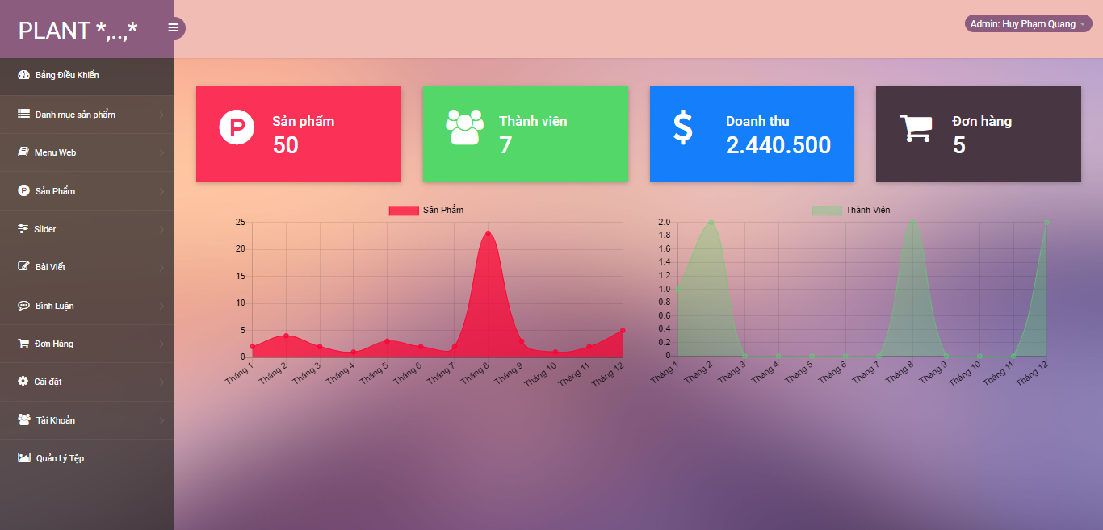

## 3.Category index page

## 4.Category edit page

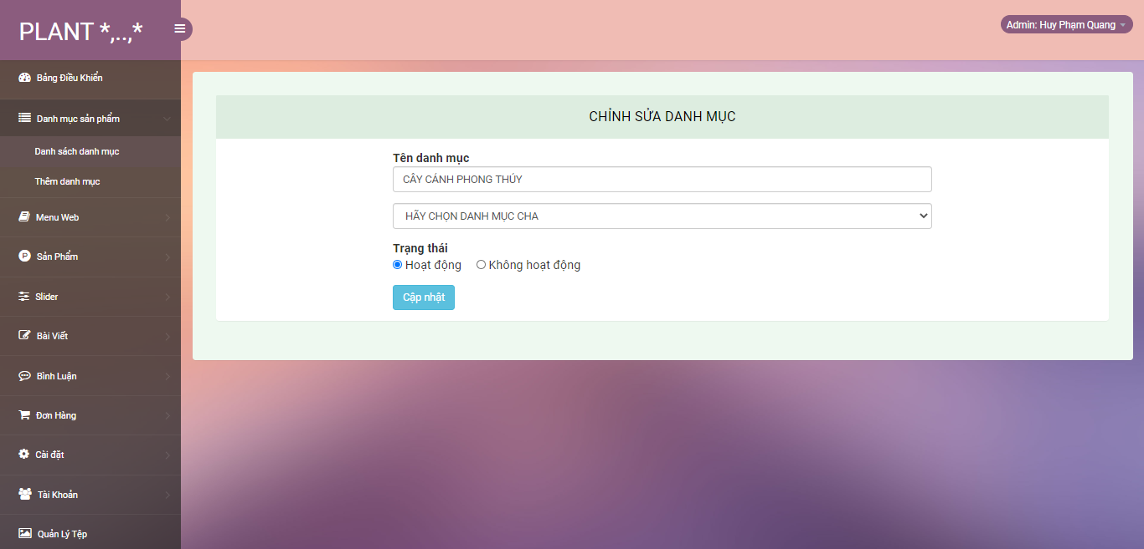

## 5.Category create page

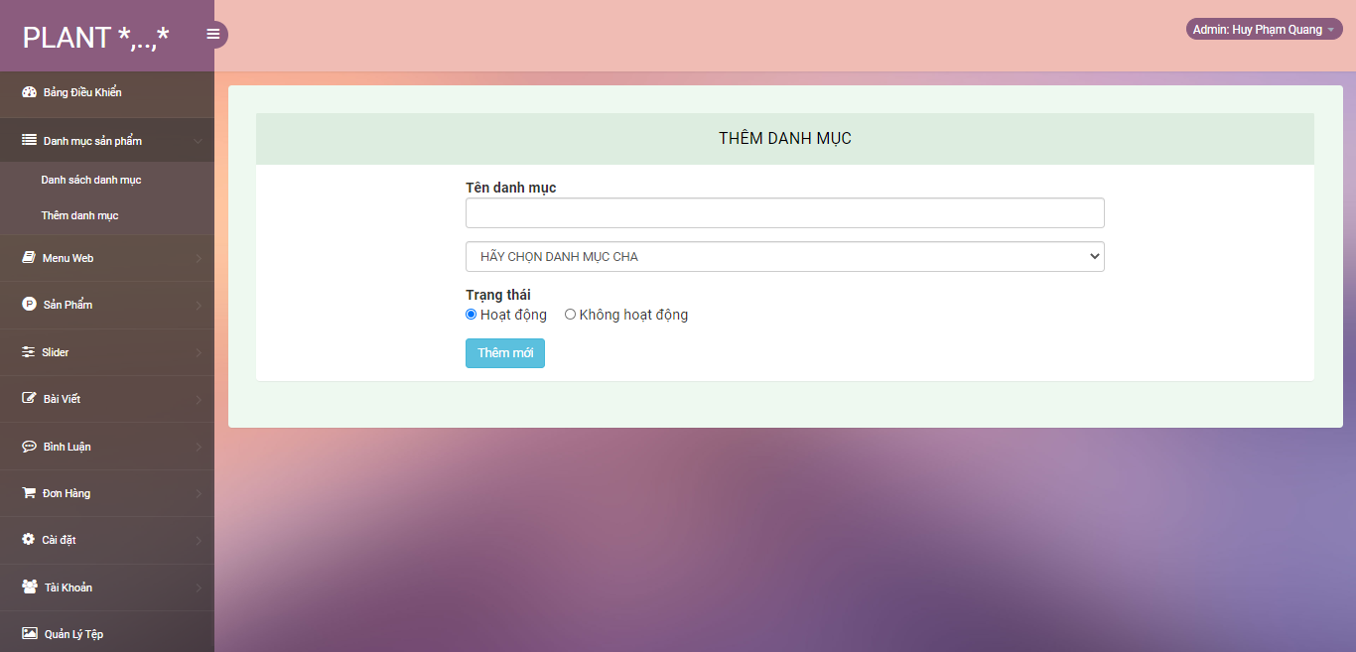

## 6.Menu index page

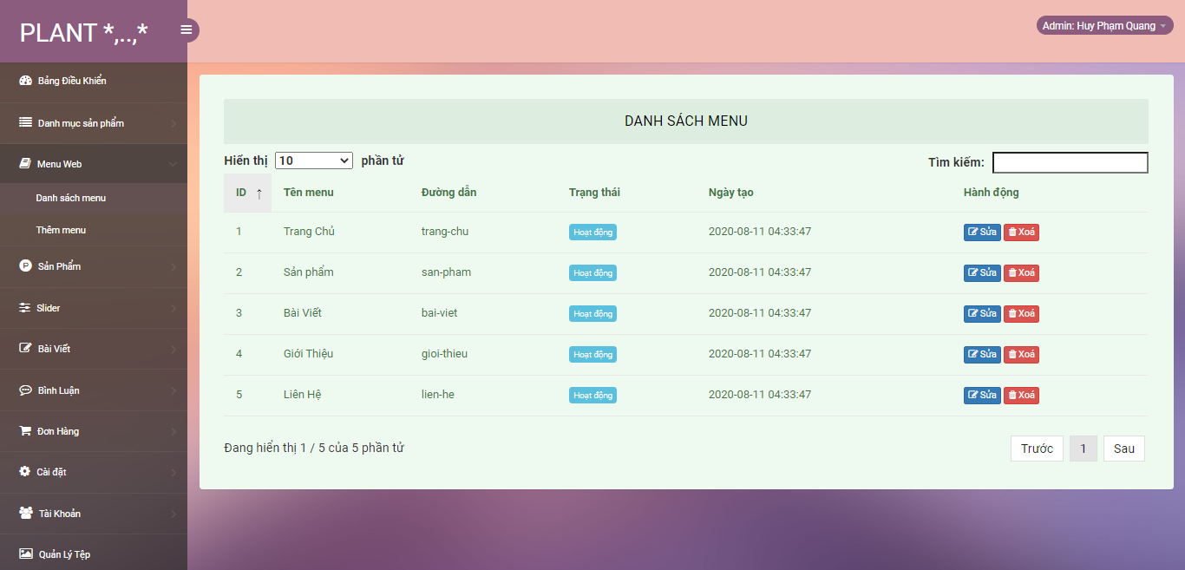

## 7.Menu edit page

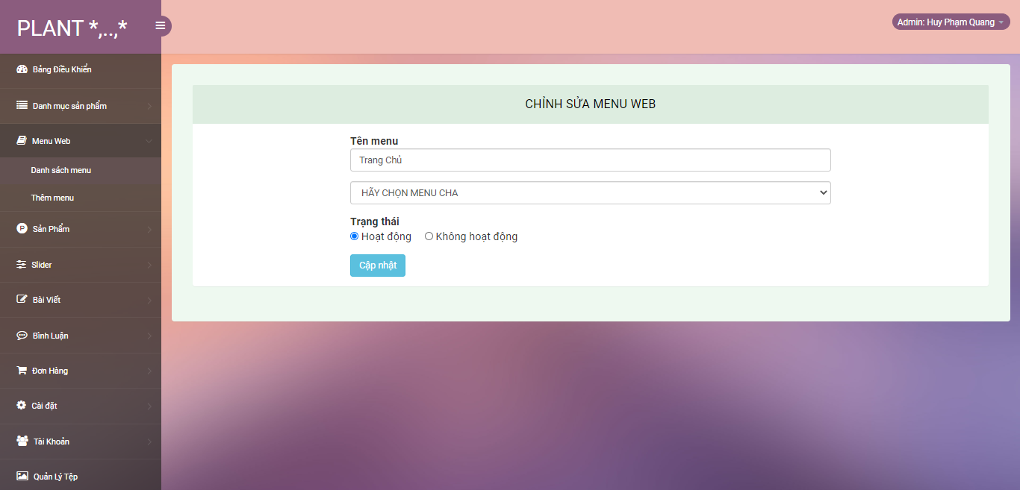

## 8.Menu create page

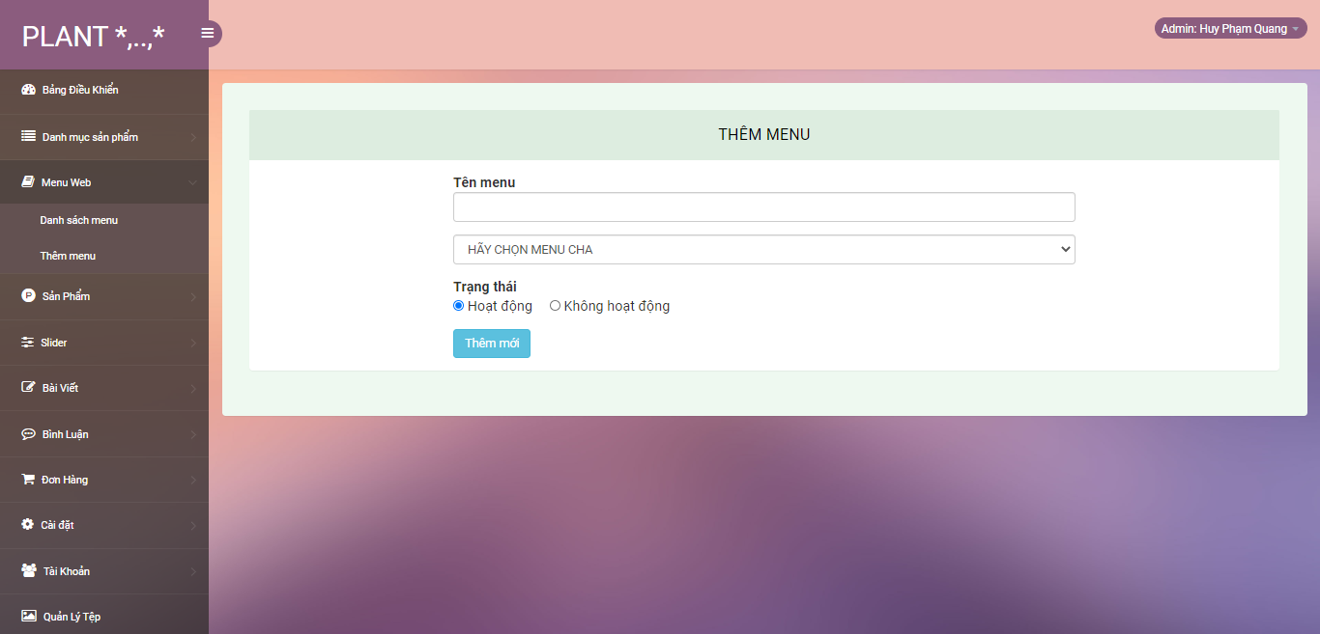

## 9.Product index page

## 10.Product edit page

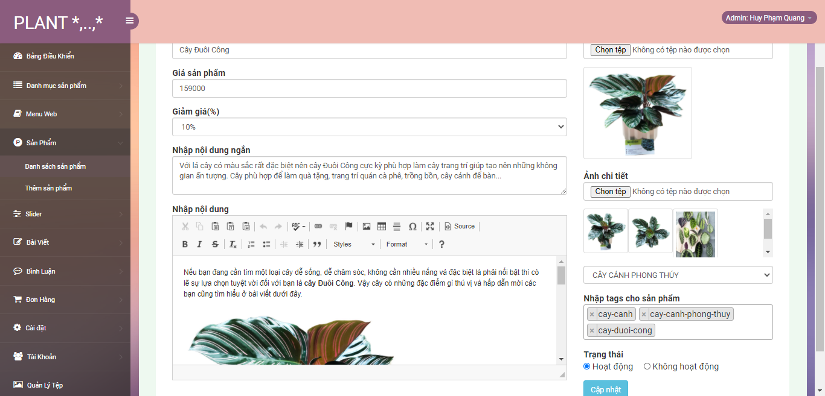

## 11.Product create page

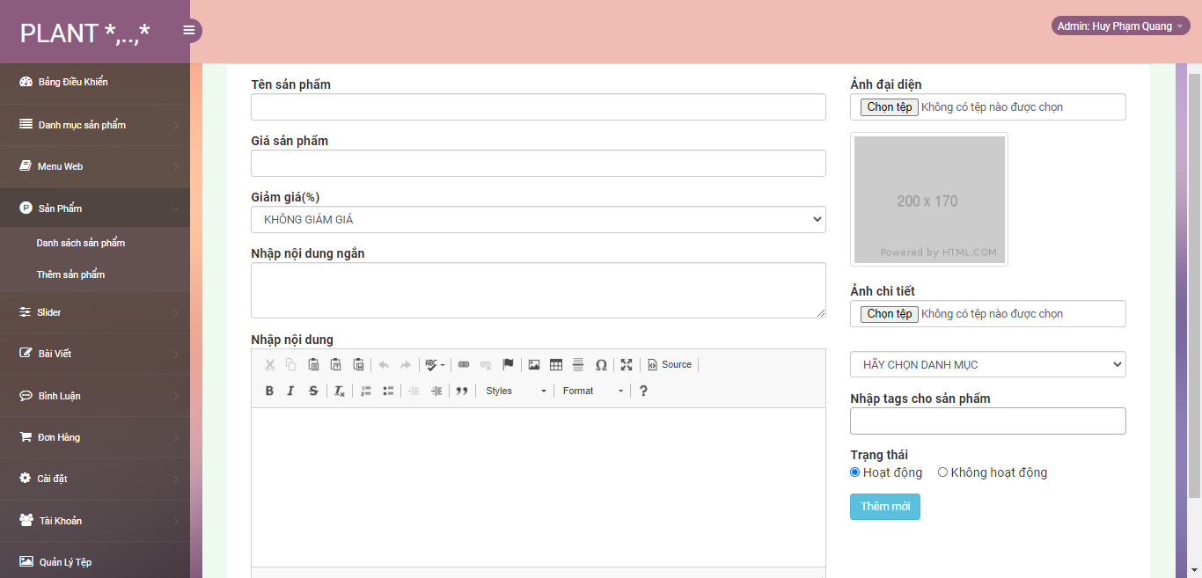

## 12.Slider index page

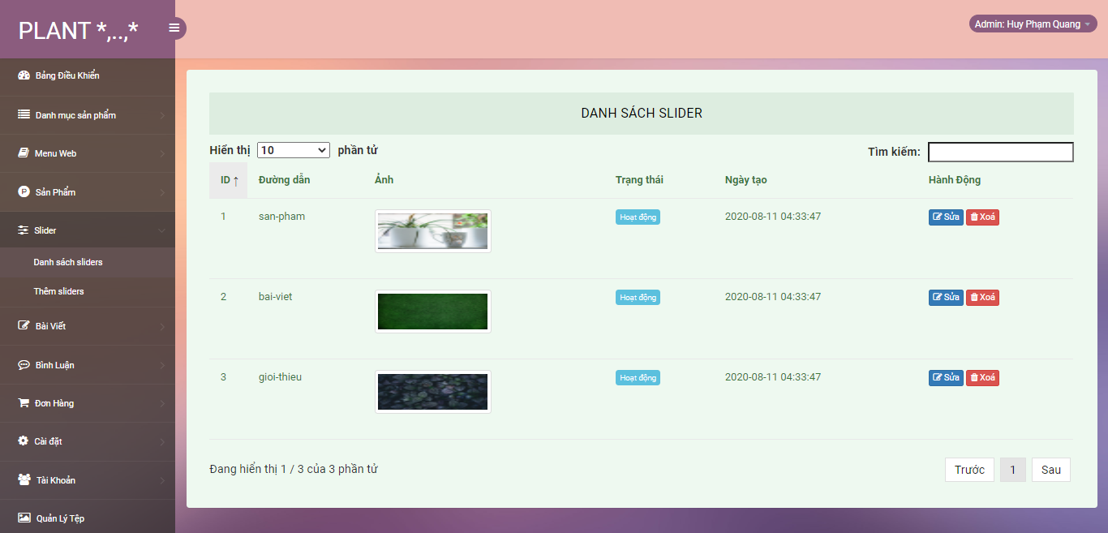

## 13.Slider edit page

## 14.Slider create page

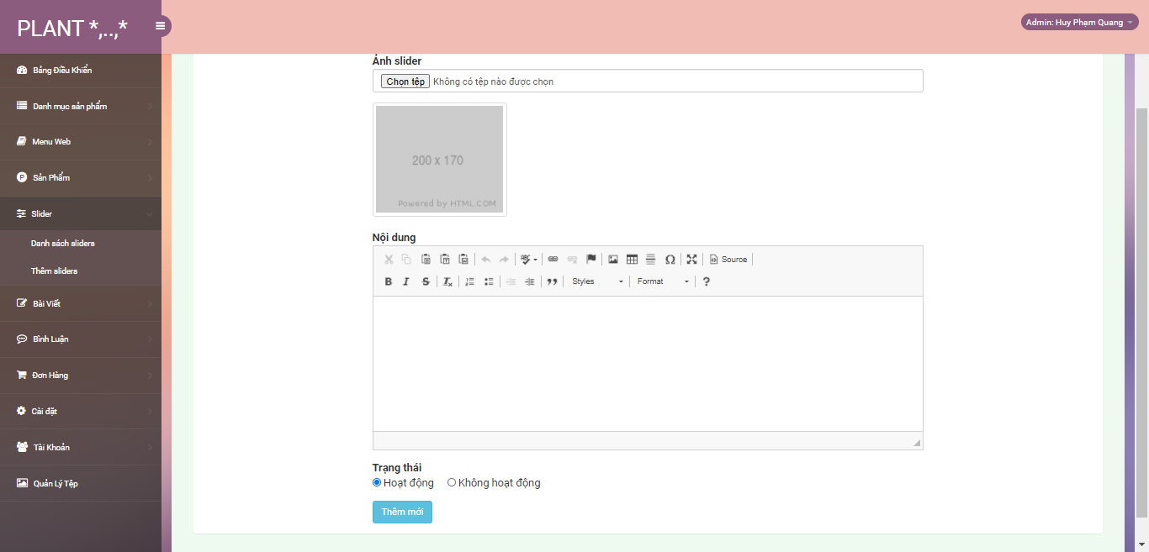

## 15.Post index page

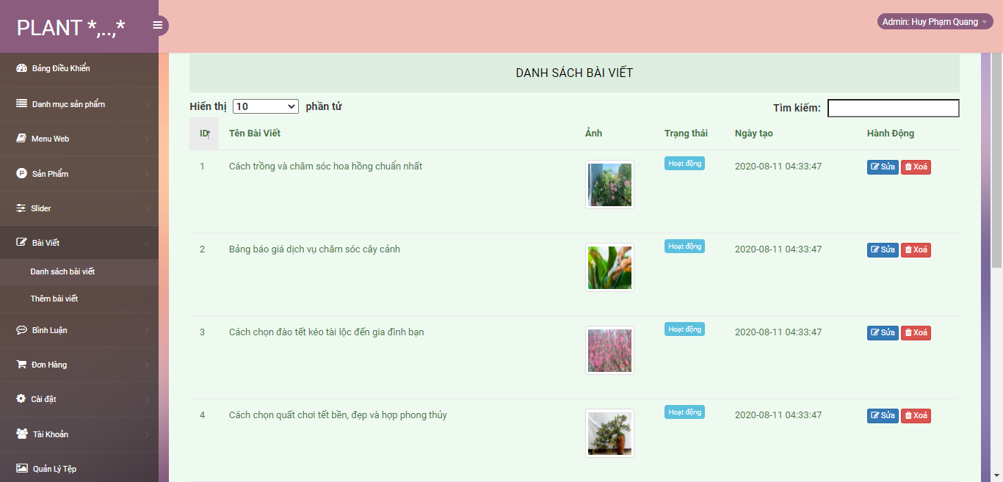

## 16.Post edit page

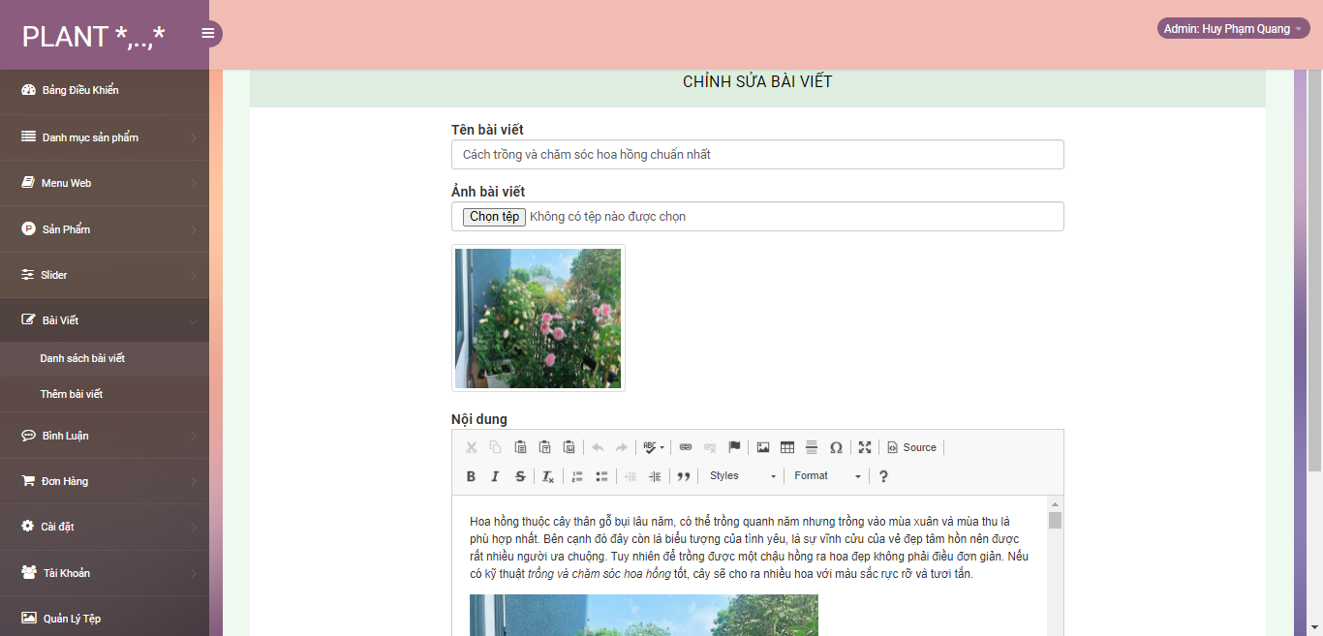

## 17.Post create page

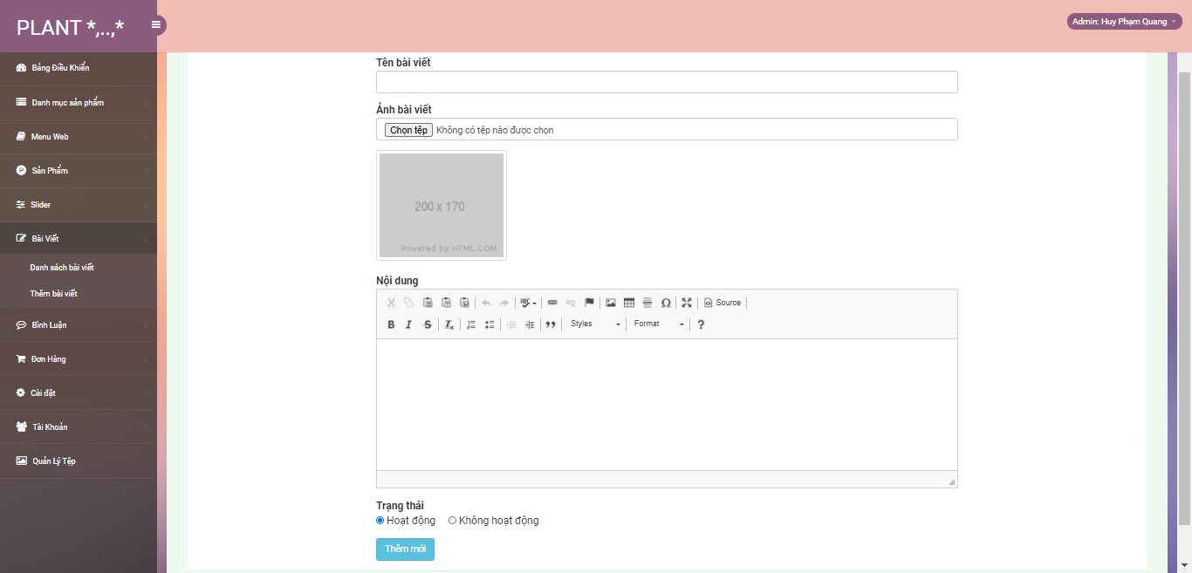

## 18.Comment index page

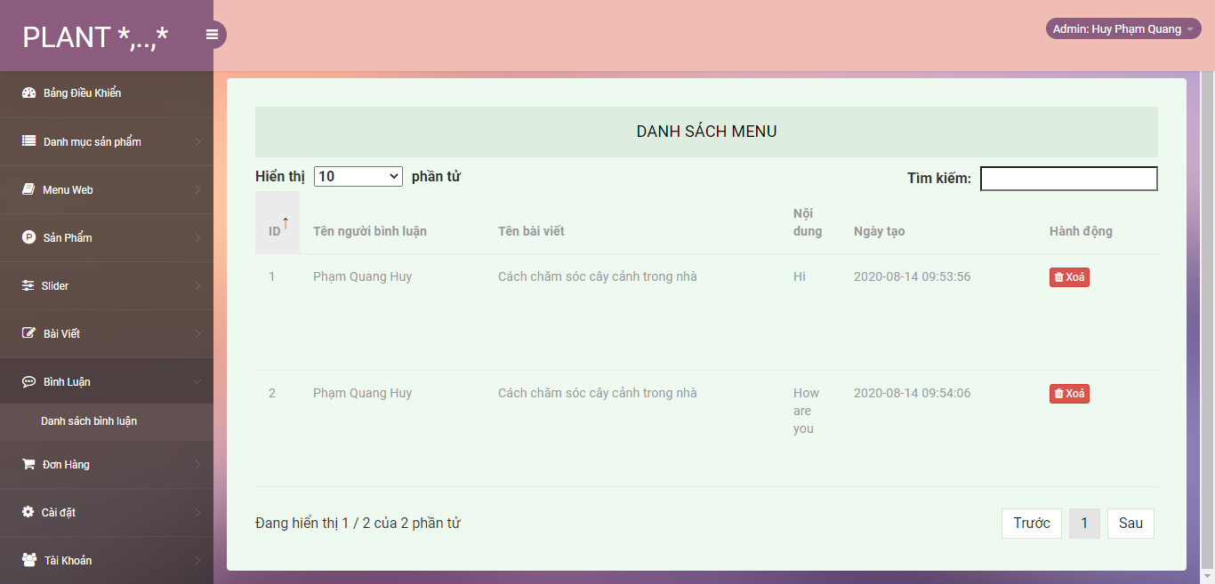

## 19.Order page

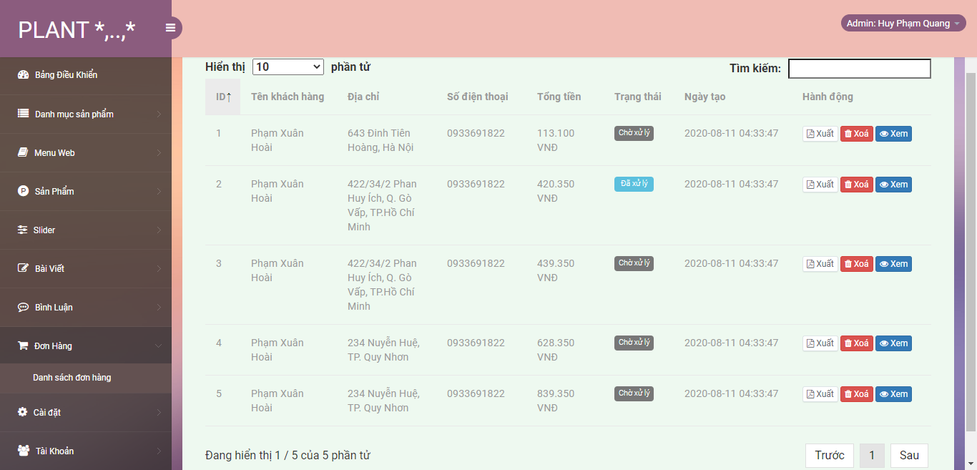

## 20.Setting index page

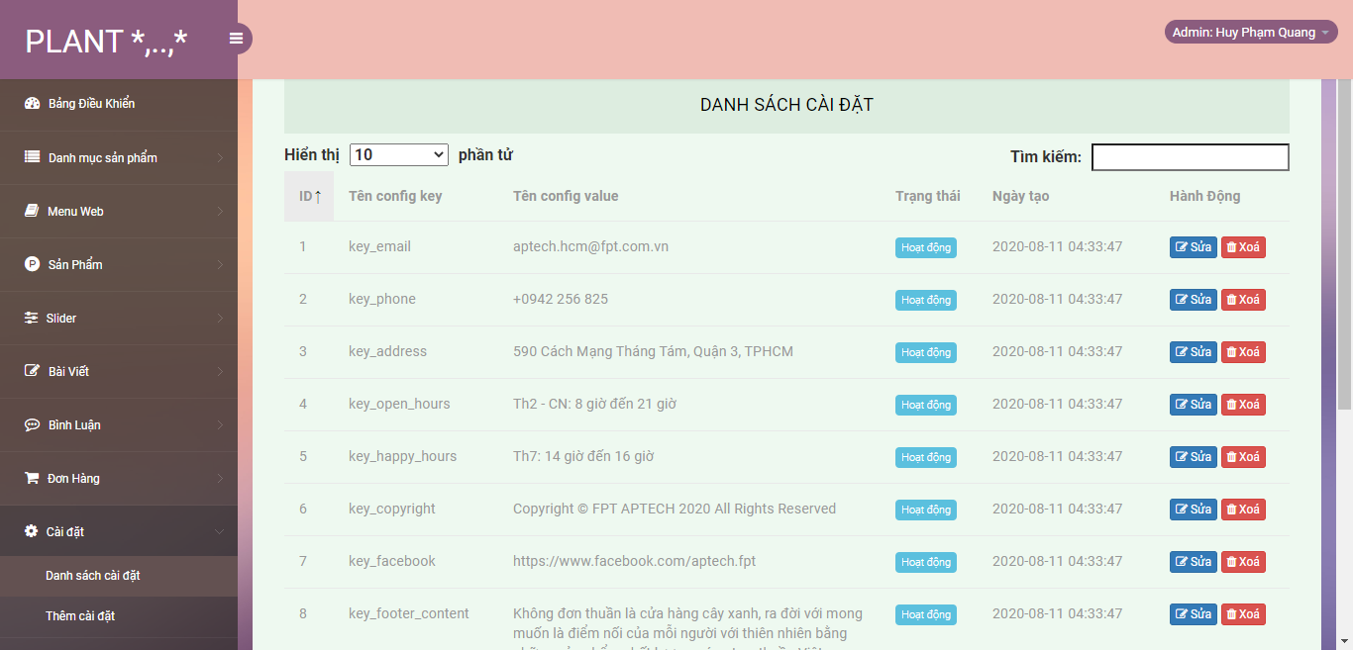

## 21.Setting edit page

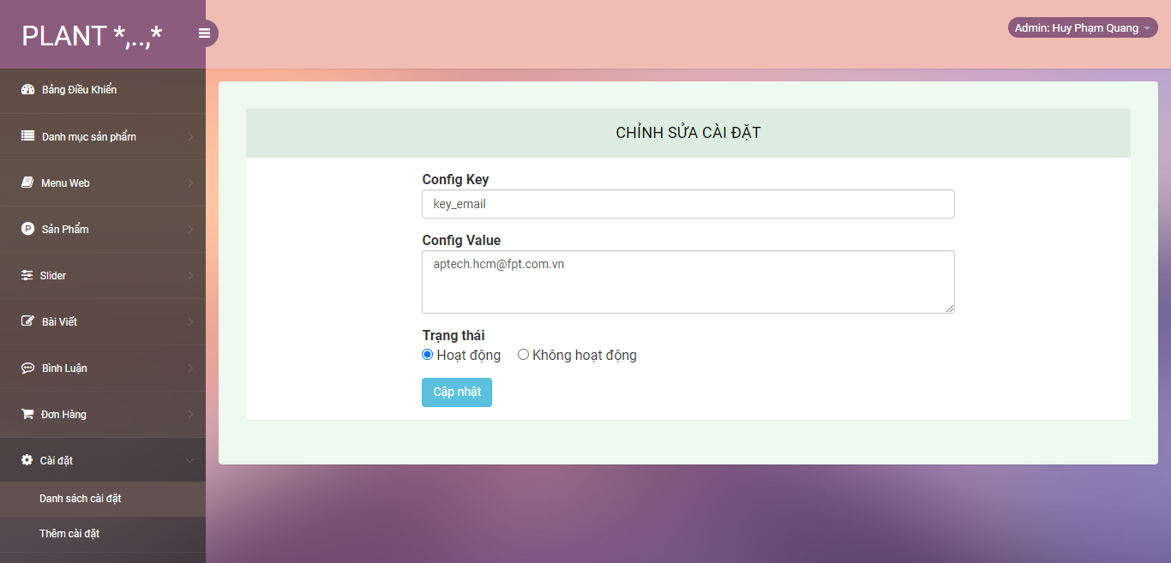

## 22.Setting create page

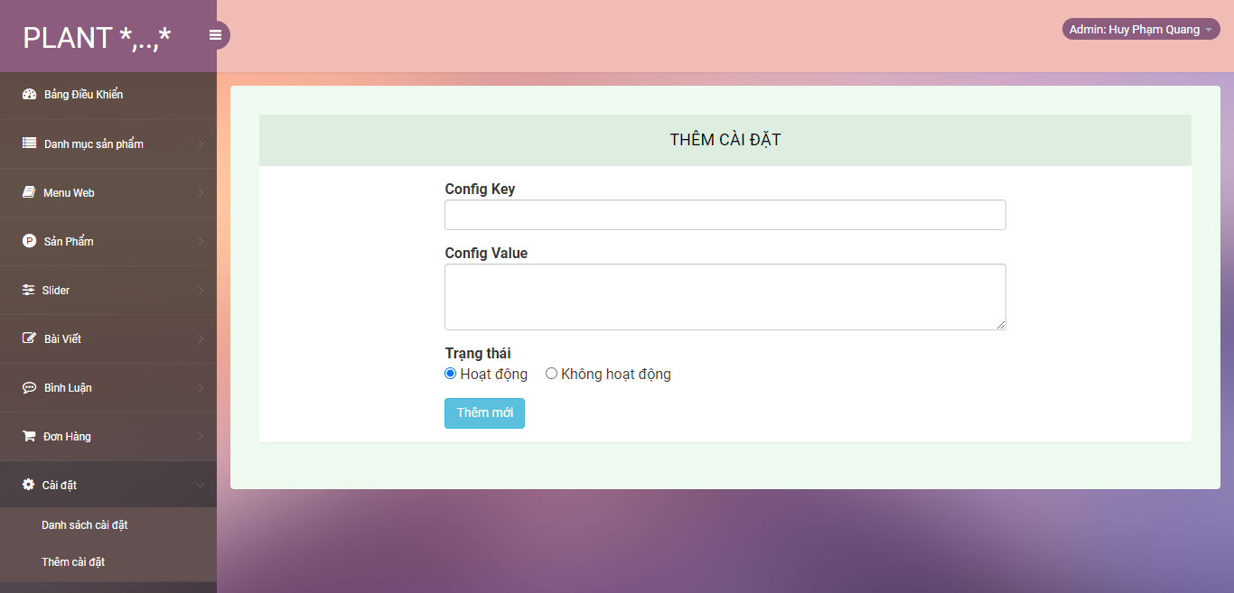

## 23.User index page

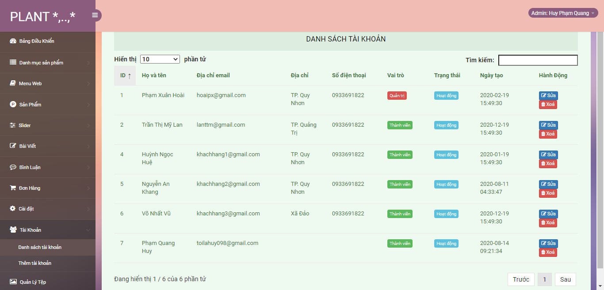

## 24.User edit page

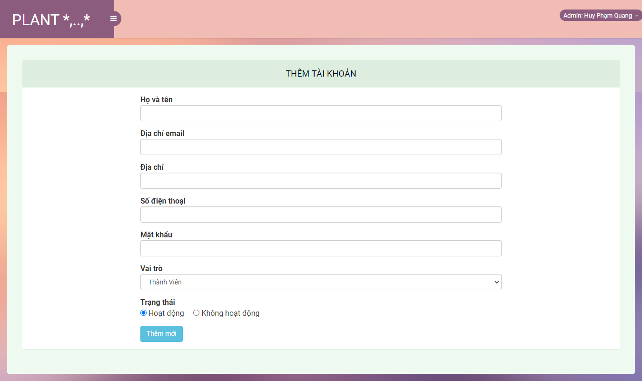

## 25.User create page

## 26.My QR

## 27.File manage page

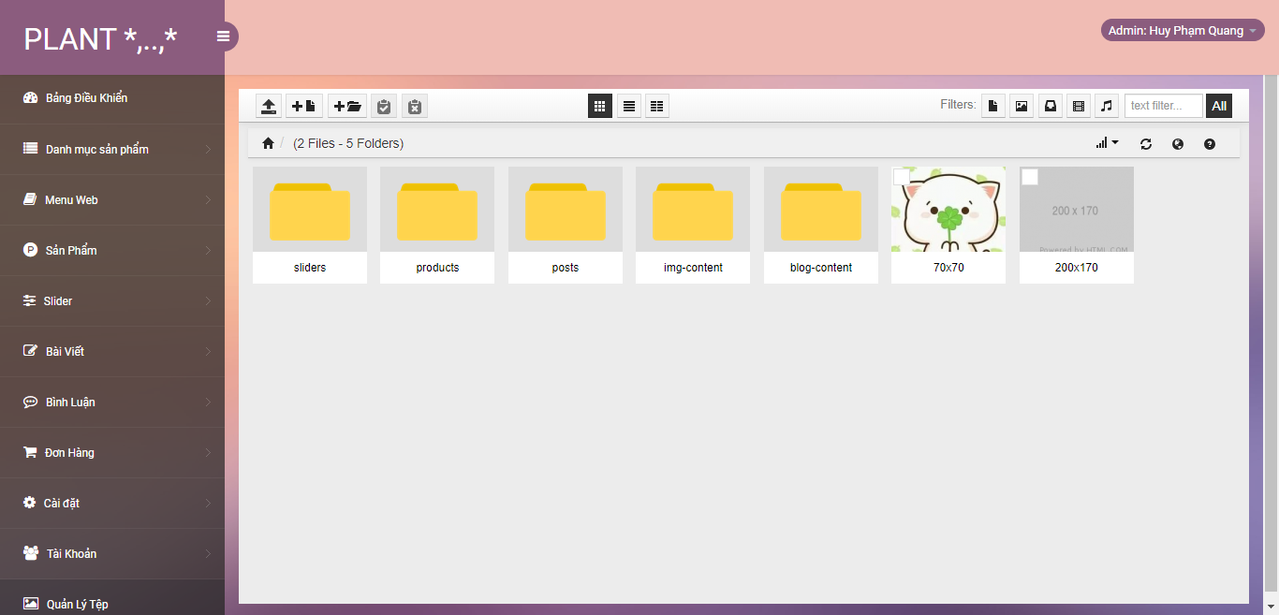

## 28.Error page(amin, guest)

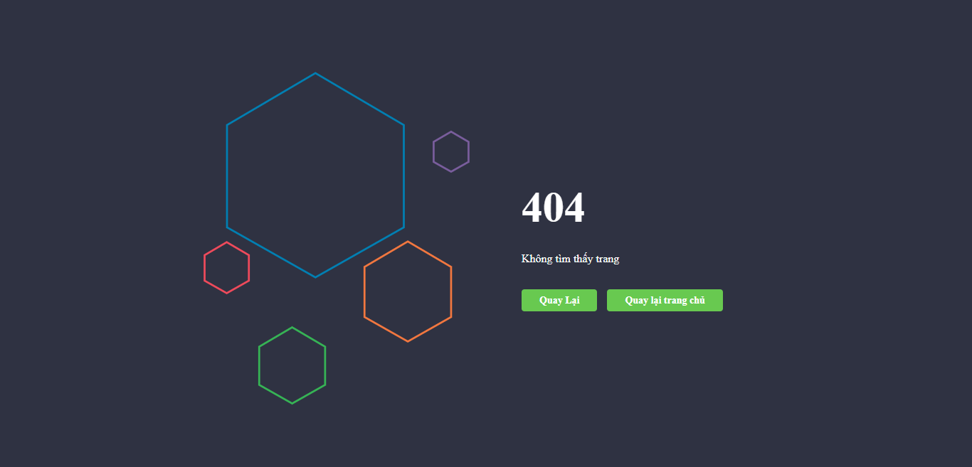

# Task Sheet

|  |  |  |  |  |
| --- | --- | --- | --- | --- |
| Project Ref.No | Project Name:Plant Store | Date of Prepration of Activity Plan | | |
| No | Description | Start date | Complete date | Team Member |
|  | Admin-Template | 2020/08/01 | 2020/08/03 |  |
|  | Admin-Login/Logout | 2020/08/01 | 2020/08/03 |
|  | Admin-Category | 2020/08/03 | 2020/08/04 |
|  | Admin-Filemanager | 2020/08/07 | 2020/08/09 |
|  | Admin-Creat migration | 2020/08/09 | 2020/08/10 |
|  | Admin-Products | 2020/08/10 | 2020/08/11 |
|  | Admin-Settings | 2020/08/10 | 2020/08/11 |
|  | Admin-Orders | 2020/08/11 | 2020/08/12 |
|  | Admin-Dashboard | 2020/08/11  Phạm Xuân Hoài  Hoài  Hoài | 2020/08/12 |
|  | Guest-Show Category | 2020/08/03 | 2020/08/05 |
|  | Guest-Cart | 2020/08/05 | 2020/08/06 |
|  | Guest-Checkout | 2020/08/05 | 2020/08/06 |
|  | Guest-Login | 2020/08/06 | 2020/08/07 |
|  | Guest-Login Facebook | 2020/08/08 | 2020/08/08 |
|  | Guest-Share Facebook | 2020/08/08 | 2020/08/08 |
|  | Guest-Comment | 2020/08/09 | 2020/08/09 |
|  | Guest-Wishlist | 2020/08/10 | 2020/08/10 |
|  | QR | 2020/08/18 | 2020/08/18 |

|  |  |  |  |  |
| --- | --- | --- | --- | --- |
| 19 | Admin-Slidebar | 2020/08/01 | 2020/08/03 |  |
| 20 | Admin-Menu | 2020/08/01 | 2020/08/03 |
| 21 | Admin-User | 2020/08/03 | 2020/08/04 |
| 22 | Admin-Create Seeder | 2020/08/04 | 2020/08/05 |
| 23 | Admin-Slider | 2020/08/05 | 2020/08/06 |
| 24 | Admin-Post | 2020/08/07 | 2020/08/07  Phạm Quang Huy |
| 25 | Admin-Comment | 2020/08/09 | 2020/08/09 |
| 26 | Guest-Template | 2020/08/06 | 2020/08/07 |
| 27 | Guest-Show Menu | 2020/08/06 | 2020/08/07 |
| 28 | Guest-Show Product | 2020/08/08 | 2020/08/09 |
| 29 | Guest-Show Post | 2020/08/09 | 2020/08/09 |
| 30 | Guest-Register | 2020/08/10 | 2020/08/10 |
| 31 | Guest-Compare | 2020/08/10 | 2020/08/10 |
| 32 | Review 1 | 2020/08/02 | 2020/08/03 |
| 33 | Review 2 | 2020/08/02 | 2020/08/03 |
| 34 | Review 3 | 2020/08/12 | 2020/08/12 |
| 35 | Report-Product | 2020/08/18 | 2020/08/18 |

|  |  |  |  |  |
| --- | --- | --- | --- | --- |
| 36 | Guest-Rating | 2020/08/01 | 2020/08/06 | Nguyễn Hoàng An |
| 37 | Guest-About | 2020/08/06 | 2020/08/09 |
| 38 | Guest-Contact | 2020/08/09 | 2020/08/11 |
| 39 | 404 Error Page | 2020/08/12 | 2020/08/14 |
| 40 | Guest-Search | 2020/08/18 | 2020/08/18 |